Introduction for software CPlayer of Iphone

I. The installation of CPlayer
1. Open the icon “App Store”（Image1），the below image will appear（Image2）；
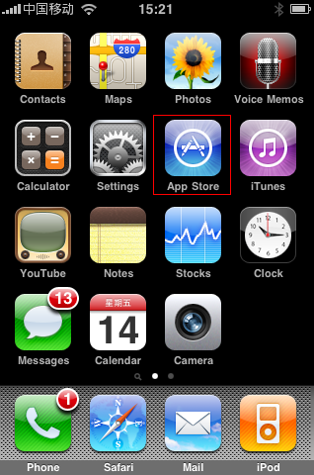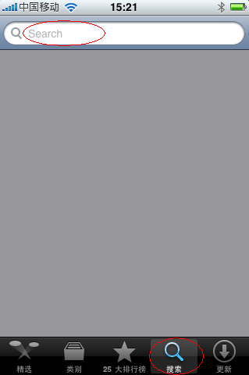
Image1 Image2
2. Input “cplayer” in the searching bar，Click “Search”（Image3）,pop Image4；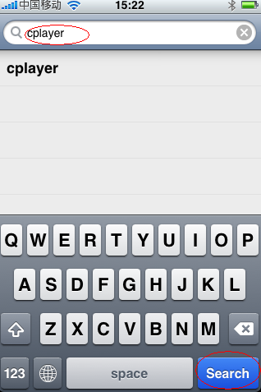 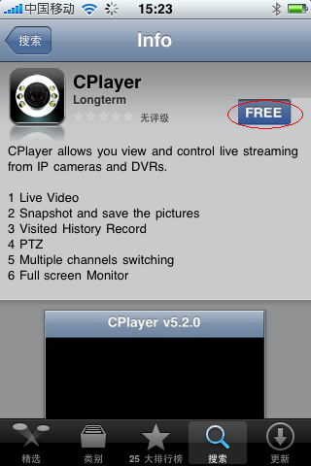
Image3 Image4

3.After click the “FREE” on image 4, the image 5 will appear, click “INSTALL” option on image 5, and the image 6 will appear. Input the password of Apple account on image 6, then click “ok”, image 7will appear.
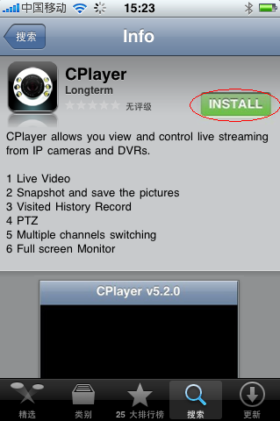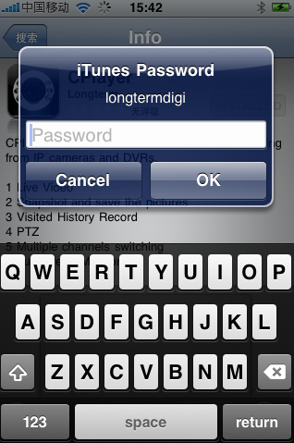
Image5 Image6
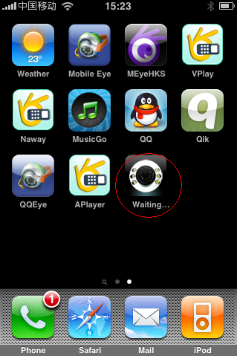
Image7

4．After “waiting…” change to “loading…” on image 8, it means it is downloading Aplayer software and set it automatically. After the process bar “” of “installing…”（Image9） is full, it means it finishes the installation.
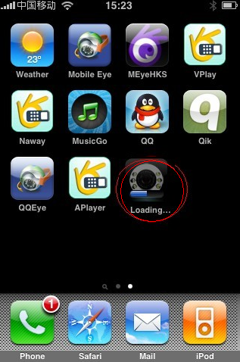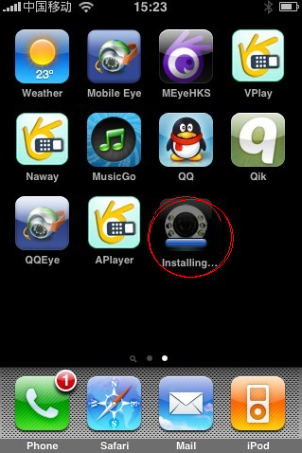
Image8 Image9
5．After finishing the installation, the interface of the mobile phone will appear CPlayer icon, like the image 10.
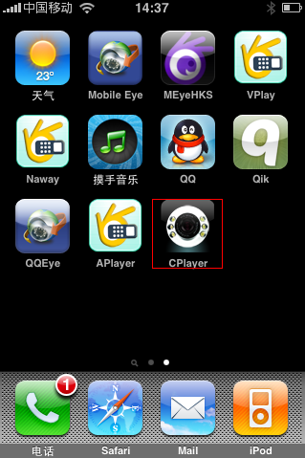
Image10

II. How to use CPlayer
1. Click Cplayer icon, open the software. The introduction of the interface function is as below:
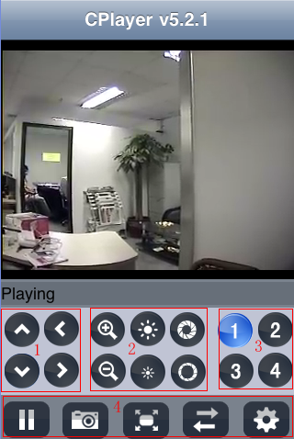
① PTZ direction key (up, down, left and right)
② PTZ lens control (magnify+, reduce-),(focus+, focus-), (iris+, iris-)
③ Choose the monitor channel
④ The function of the key from left to right: Pause, capture, full screen mode, next monitor option, monitor connection setting.
⑤ Exit, the middle key of the phone

2. Set the monitor point: it is the same setting with Symbian and Windows.
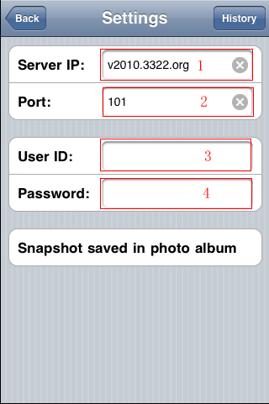
① IP address of the monitor point
② Network port
③ User name
④ Password

