Mobile Phone Surveillance User Mannual

Catalogue

Catalogue 0
1 Symbian System 1
1.1Brief Introduction 1
1.2 Installation and Operation Instructions 1
2 Windows mobile System 4
2.1 Brief Introductions 4
2.2 Installations and Operations Instructions 5
3 iPhone 10
3.1Brief Instructions 10
3.2 Installations and Operation instructions 10
4 Blackberry 14
4.1 Brief Instructions 14
4.2 Installation and Operation Instructions 14
5 Android 21
5.1Brief Instructions 21
5.2 Installation and Operation Instructions 21

1 Symbian System

1.1Brief Introduction
The main functions and characteristics of the Mobile Phone(Symbian System) are as below:
Real time viewing video function
PTZ control function(front end is the controllable dome camera)

Prerequisite
The mobile phone should support 9.1 Version Symbian System(just as said the Third and Fifth Generation of the Symbian System) such as Nokia 6120c, Nokiae71 and Nokia5800( all the mobile phones with a resolution of 240*320,320*240 in the third generation and a resolution of 360*640,640*360 in the fifth generation.

1.2 Installation and Operation Instructions
1) Open the 'Symbian' folder of the CD disk files,then transfer the files(KMEYE_3rd sisx or KMEYE_5rd sisx) to the mobile phone for the installation on the phones

Note:KMEYE_3rd.sisx support Symbian system of the Third Generation,KMEYE_5th.sisx support Symbian system of the Fifth Generation

There will be the programme icon on the mobile phones, try to find the KMEye under the designated root catalogue,as shown in the following image:
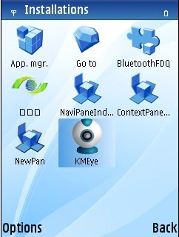

2) Click KMEye programme icon to enter into the interface as shown in the following image:
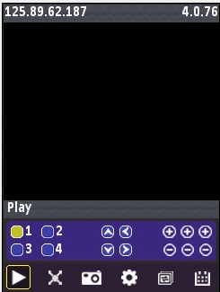

The corresponding functions of the Buttons:
Function Key | Name | Descriptions of the functions
 | PLAY | Connect the device and play the video
 | Screenshot | Screenshot of the available images(Save the screenshot image to the defaulted photo root of the mobile phones)
 | Setting | Setting of the IP address, dynamic domain name,Port number,user,password and device names
 | Next Channels | Select to the next Channels
 | Exit | Exit
 | Full Screen | Full Screen Viewing
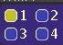 | Channel Selection | Select to play the video of one channel
 | PTZ Control | To control the PTZ(UP,DOWN,RIGHT,LEFT)
 | Focus,Zoom,Iris | To widen and Truncate, adept the focus distance

3) If using the mobile viewing for the first time or any need to modify the parameters,please click 'Setting' button to enter into the interface of parameter setting as shown in the following image:
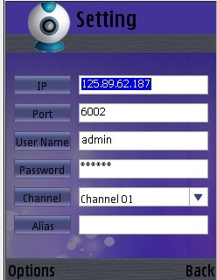
Note:

Server Address: The IP address or Dynamic domain name of the DVR IE
Server Port:The server port on the DVR
Device Name:the alias to differentiate the different devices
User ID: The same user name with the name set on IE
Password:The same password with the password set on IE
alias:create the corresponding alias.So the alias will appear the alias on the interface

Open the menu to enter into the list of the history record, or click the PLAY&BACK button to play,then the setting will be saved. The setting will not be saved if clicking BACK directly.

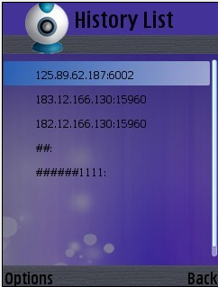
Select one of the history records and open the menu,then click OK to see the viewing

Deleting one history record
Select the record file to be deleted and open the menu,then click the delete button to delete the file
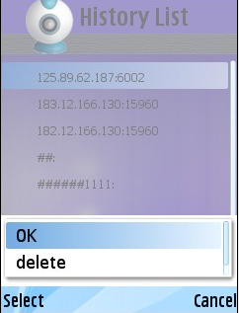
4) Video Display Format
The switching between regular format and full screen format
Regular Format
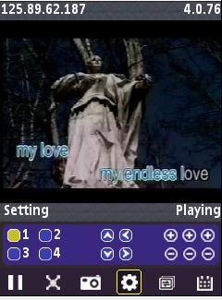

When extending the mobile phone,the video will be played with full screen automatically.

5)Channel Switching
Select any of the channels,then the programme will open the corresponding channel and also play the record video automatically. The defaulted programme setting is 1-4 channel, when you click the NEXT option, the channel number will be switched between 5-8,8-12,12-16 accordingly.

2 Windows mobile System

2.1 Brief Introductions
The main functions and characteristics of the Mobile Phone(Windows Mobile System) are as below:
Real time viewing video function
PTZ control function(front end is the controllable dome camera)

Prerequisite
The mobile phone should support the Windows Mobile 2003 version or updated versions(only touch screen version supported for the present)

2.2 Installations and Operations Instructions

1) Open the 'Windows Mobile' folder of the CD disk files,then transfer the files(KMEyesetup.cab) to the mobile phone for the installation on the phones

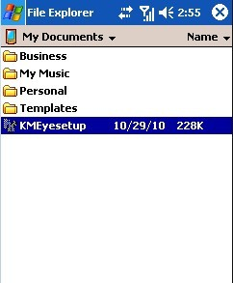

2) Try to find the KMEyesetup.cab under the designated file root, double-click it to install. After the installation, there will be the icons as following image:
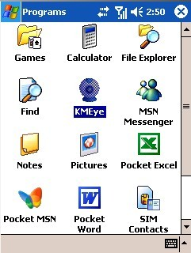

3) Click KMEye Icon to enter into the interface as following image:
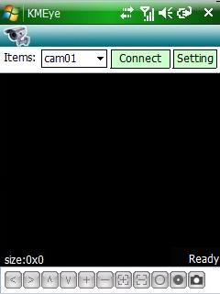

The corresponding functions of the Buttons:

Function Key | Name | Function Description
 | Connect and Play | Connect the device and begin to play the video
 | Setting | Setting of the IP address, dynamic domain name,Port number,user,password and device names
 | Stop | Stop the Video Playing
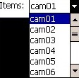 | Channel Selection | Select to play one video of one channel on the device
 | PTZ Control | To control the PTZ(UP,DOWN,RIGHT,LEFT)
 | Zoom | Zoom
 | Focus | Change the focus distance
 | Iris | Change the Iris
 | Screenshot | Screenshot of the available image,the screenshot file is saved under the installation root as follows:  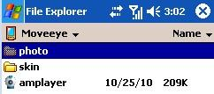  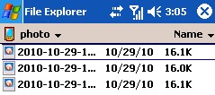

4) If using the mobile viewing for the first time or any need to modify the parameters,please click 'Setting' button to enter into the interface of parameter setting as shown in the following image:

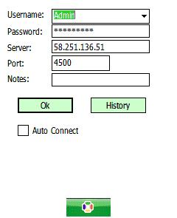

Server Address: The IP address or Dynamic domain name of the DVR IE
Server Port:The server port on the DVR
Device Name:the alias to differentiate the different devices
User ID: The same user name with the name set on IE
Password:The same password with the password set on IE
alias:create the corresponding alias.So the alias will appear the alias on the interface

Click History button to enter into the history record interface
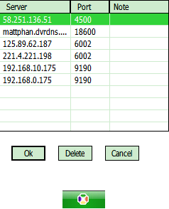
Select the record to be deleted,then press the Delete button to delete the record

Select one of the records and press OK button and then back to Setting interface

Then press OK button to enter into the connecting interface
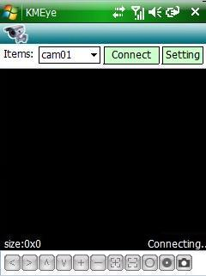

Enter into the PLAY interface after the successful connecting
5)Video Display Mode
The switch between Regular Mode and Full Screen Mode
Regular Mode
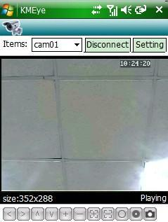
Click Disconnect Button to stop the playing

Full Screen Mode
Click the Screen with the finger or Mobile screen pen to switch into the full screen play
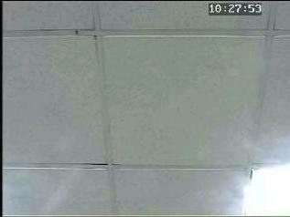

Click the Screen with the finger or Mobile screen pen when full screen playing,the screen will be switched into the regular play mode

6）Channel Switching

Click to select the corresponding Channels,the program will open the corresponding channel and play hte record video automatically.

3 iPhone

3.1Brief Instructions
The main functions and characteristics of the Mobile Phone(Iphone) are as below:
Real time viewing video function
PTZ control function(front end is the controllable dome camera)

Prerequisite
The mobile phone should support the iOS 3.0 version or updated versions(Including Iphone and Ipod touch)

3.2 Installations and Operation instructions
1) To operate the APP Store Programme on IPHONE and switch into the search label web,then enter KMEye in the search column to find the corresponding programme installation files package. After that,click the file to install as shown in the following image:
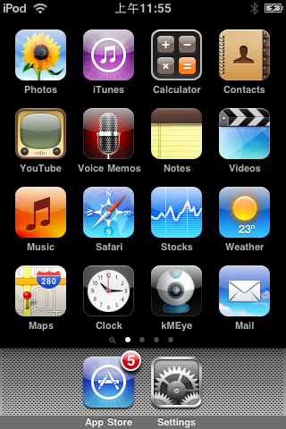

2)Click KMEye Programme Icon to enter into the following image:

The corresponding functions of the Buttons:
Function Key | Name | Function Description
 | Play | Connect the device and play the video
 | Screen Shot | Screenshot of the available images(Save the screenshot image to the defaulted photo root of the mobile phones)
 | Setting | Setting of the IP address, dynamic domain name,Port number,user,password and device names  Select to the next Channels
 | Next Group | Selection of next group
 | About | About Info
 | Channel Selection | select to play the video of one channel
 | PTZ Control | To control the PTZ(UP,DOWN,RIGHT,LEFT)
 | ZOOM | ZOOM
 | Focus | Change the focus distance
 | Iris | Change the Iris

3) If using the mobile viewing for the first time or any need to modify the parameters,please click 'Setting' button to enter into the interface of parameter setting as shown in the following image:

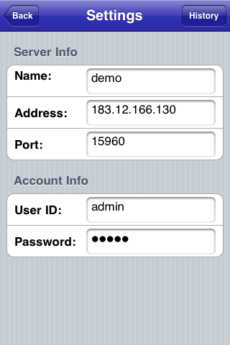

Server Address: The IP address or Dynamic domain name of the DVR IE
Server Port:The server port on the DVR
Device Name:the alias to differentiate the different devices
User ID: The same user name with the name set on IE
Password:The same password with the password set on IE
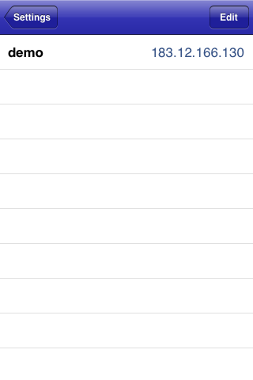

Click History button to enter into the history record interface

Delete of one history record
Click 'Edit' button and click the red round button in one of the records as shown in the following image, then click Delete button
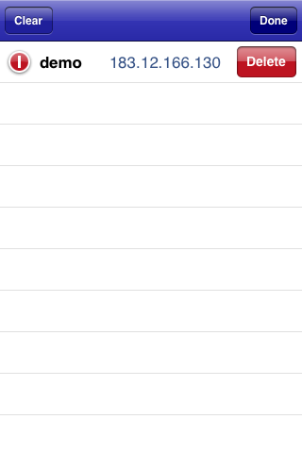
4)Video Display Mode
Switch between Regular Mode and Full Screen Mode
Regular Mode
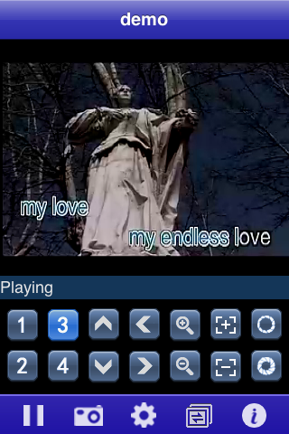

When lying the mobile phone,the video will automatically be displayed with full screen.

- Channel Switching
Select any of the channels,then the programme will open the corresponding channel and also play the record video automatically. The defaulted programme setting is 1-4 channel, when you click the NEXT option, the channel number will be switched between 5-8,8-12,12-16 accordingly.

4 Blackberry

4.1 Brief Instructions
The main functions and characteristics of the Mobile Phone(Iphone) are as below:
Real time viewing video function
PTZ control function(front end is the controllable dome camera)

Prerequisite

The mobile phone should support 4.6 Version Blackberry System such as Blackberry 8900, Blackberry 9000, Blackberry 9700 and Blackberry 9630 with a resolution of 480*360 and 480*320.

4.2 Installation and Operation Instructions

1) Open the 'Blackberry' folder of the CD disk files,then transfer the files(KMEYE.cod or KMEYE.alx) to the mobile phone for the installation on the phones

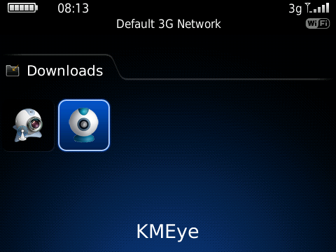

Click the Options on the Mobile Phones to enter into the following interface:

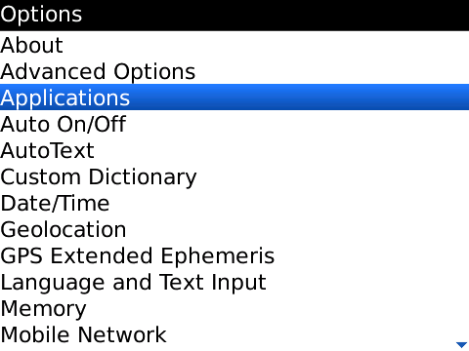

Click 'application' option to find the KMEye,then click 'Authority Edit' to set all the authority as 'allow'
2) Click KMEye program icon. After that, enter into the initialization interface as shown in the following image:
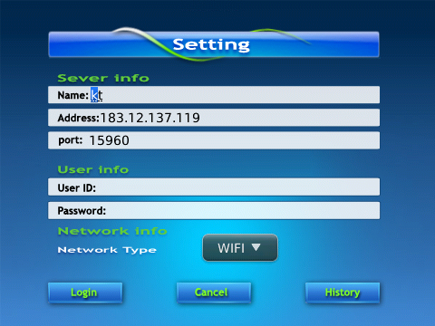

Server Address: The IP address or Dynamic domain name of the DVR IE
Server Port:The server port on the DVR
Device Name:the alias to differentiate the different devices
User ID: The same user name with the name set on IE
Password:The same password with the password set on IE
Network Type:Select the desired web
The corresponding functions of the Buttons:

Function Key | Name | Function Description
 | Login | Enter into the PLAY main interface,then the program is connected to the device and begin to play the video
 | Cancel | Exit to the program
 | History | Enter into the history record interface

Click LOGIN to enter into the PLAY main interface
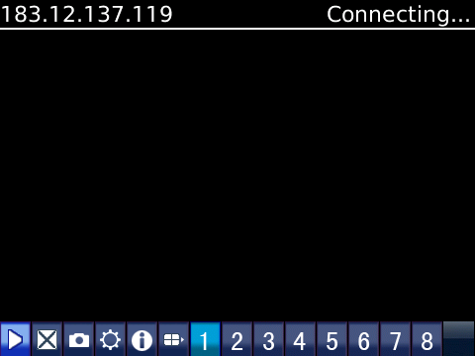

The corresponding functions of the Buttons:

Function Key | Name | Function Description
 | PLAY | Connect the device and play the video
 | FULL SCREEN | FULL SCREEN PLAY
 | Screenshot | Screenshot of the available images(Save the screenshot image to the defaulted photo root of the mobile phones)
 | Setting | Setting of the IP address, dynamic domain name,Port number,user,password and device names
 | Next Group | Select to the next group
 | About | About Info
 | Channel Selection | select to play the video of one channel
 | PTZ Control | To control the PTZ(UP,DOWN,RIGHT,LEFT)
 | ZOOM | ZOOM
 | Focus | Change the focus distance
 | Iris | Change the Iris
Click Cancel and exit the program as shown in the following image:

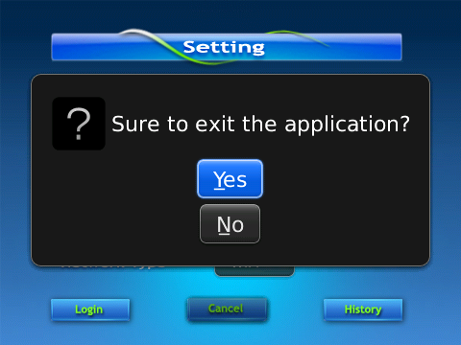

3) Click 'History Record' to enter into the history record list as shown in the following image:

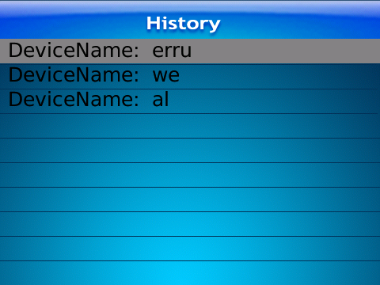

Click the menu button to pop-up the menu

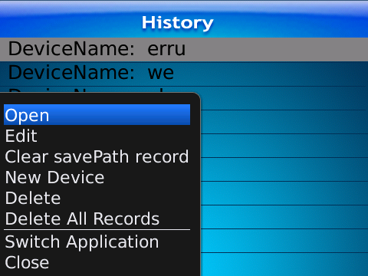

The corresponding functions of the menu are as following
Function Key | Name | Function Description
open | PLAY | Connect the device and play the video
edit | EDIT | EDIT RECORD
Clear savePath record | CLEAR | Clear savePath record
New Device | New Device | New added record
Delete | delete | delete the records
Delete All Records | Delete All Records | Delete All Records
Switch Application | Switch Application | Switch Application
Close | Close | Close the program

4)Video Display Mode
The switch between the regular mode and full-screen mode
Regular Mode

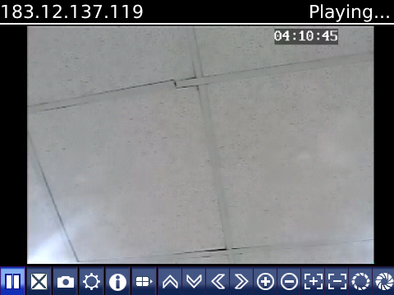

Full Screen Mode

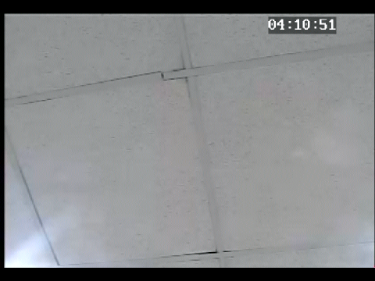

5 Android

5.1Brief Instructions

The main functions and characteristics of the Mobile Phone(Android) are as below:
Real time viewing video function
PTZ control function(front end is the controllable dome camera)

Prerequisite

The mobile phone should support 1.5 Version Android System such as HTC G1,HTC Magic,HTC Hero,HTC G5 and so on .

5.2 Installation and Operation Instructions
1) Open the 'Android' folder of the CD disk files,then transfer the files(KMEye.apk) to the mobile phone for the installation on the phones

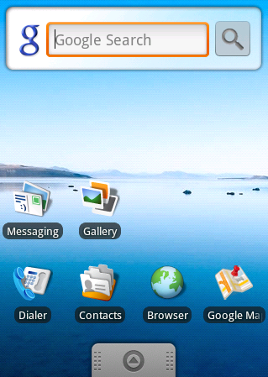

2)Try to find the KMEye.apk under the designated root and click the Ultilization Program to finish the installation
3) Click the KMEye Icon to enter into the following interface:
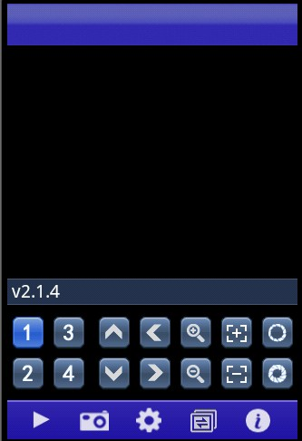

The corresponding functions of the Buttons:

Function Key | Name | Function Description
 | PLAY | Connect the device and play the video
 | Screenshot | Screenshot of the available images(Save the screenshot image to the defaulted photo root of the mobile phones)
 | Setting | Setting of the IP address, dynamic domain name,Port number,user,password and device names  Select to the next Channels
 | Next Group | Select to the next group
 | About | About Info
 | Channel Selection | select to play the video of one channel
 | PTZ Control | To control the PTZ(UP,DOWN,RIGHT,LEFT)
 | ZOOM | ZOOM
 | Focus | Change the distance of focus
 | IRIS | Change the IRIS

4) If using the mobile viewing for the first time or any need to modify the parameters,please click 'Setting' button to enter into the interface of parameter setting as shown in the following image:
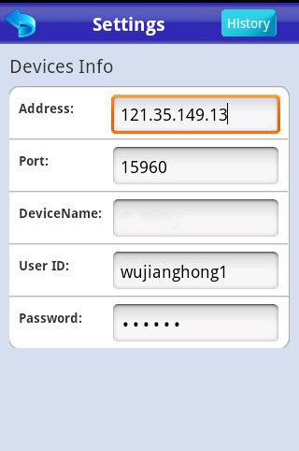

Server Address: The IP address or Dynamic domain name of the DVR IE
Server Port:The server port on the DVR
Device Name:the alias to differentiate the different devices
User ID: The same user name with the name set on IE
Password:The same password with the password set on IE
 is the Back button
 is referred as the entry of the history record interface
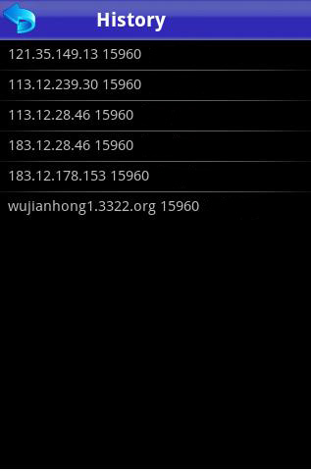

Select one of the record in the history record list to watch the video

Delete of one history record

Select the record to be deleted and click it to pop up a selection column.select delete option to delete the history record
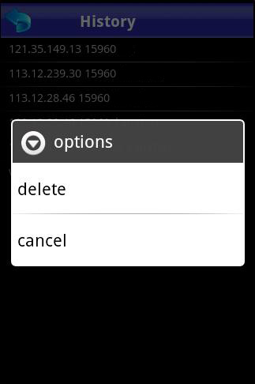
5)Video Display Mode
The switch of the Regular Mode and Full Screen Mode
Regular Mode
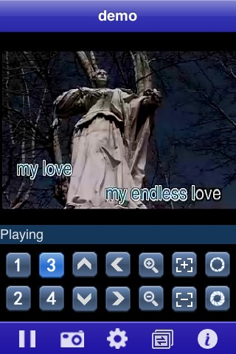

When the mobile phone is lying,the video is played with full screen automatically
Full Screen Mode
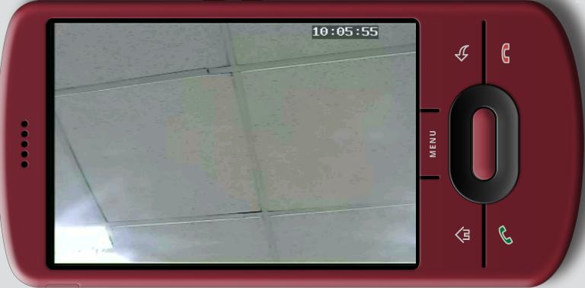

6)Channel Switch

Select any of the channels,then the programme will open the corresponding channel and also play the record video automatically. The defaulted programme setting is 1-4 channel, when you click the NEXT option, the channel number will be switched between 5-8,8-12,12-16 accordingly.

