**UC Video Surveillance Client**

**User Manual**

**V1.2.5**

**Statement**

Thank you for purchasing our products! If you have any questions or need, please contact the customer department at any time.

This manual applies to UC video surveillance client software.

There may be technical inaccuracies and typographical errors in the manual. Products, updated in real time, the contents of the manual will be updated from time to time without prior notice. The updated content will be added in new version. If it is inconsistent with the products, please be on the products basis.

If in doubt or dispute manual, please refer to the final interpretation of the company.朗读

**Note for user manual**

Video surveillance client is powerful monitoring software, set multiple windows, multi-user, voice intercom, multiple windows, multi-user, playback, TV Wall, Map, Forward Service Setting, Multi-screen display control compatible with other extension products, Single straight even device monitoring system is an organic whole for the function such as.

Video surveillance system is aimed at connecting more than one different type or model of equipment (such as IPC, NVS, NVR, etc.), this manual only for professional network video surveillance system of the client software operation are described, relate to a specific device feature setting, please read the product manual.

This manual is for the use of video surveillance system provided by the user. You should have the relevant equipment (such as IPC, NVS, NVR, etc.) of the basic operational knowledge and experience.

CONTENTS

Chapter1 Features - 1 -

1.1 Main Features - 1 -

2.1 Hardware environment - 3 -

2.2 Software Environment - 3 -

Chapter3 Install and Uninstall - 4 -

3.1 Installation Steps - 4 -

3.2 Uninstall Steps - 7 -

Chapter4 Config Management - 8 -

4.1Main Interface description - 10 -

4.2 Device Config - 12 -

4.2.1 Device Group Config - 12 -

4.2.2 Device Config - 13 -

4.3 User config - 15 -

4.3.1 Role config - 15 -

4.3.2 User group config - 15 -

4.3.3 User management - 16 -

4.3.4 Rolling Subtitles Management - 16 -

4.4 Record Config - 17 -

4.4.1 Record strategy - 17 -

4.4.2 Strategy config - 17 -

4.5 Remote Config - 19 -

4.5.1 Select device - 19 -

4.5.2 Remote config - 20 -

4.6 Maintenance - 20 -

4.6.1 Device information list - 20 -

4.6.2 Upgrade - 20 -

4.6.3 Config file Upload and Download - 21 -

4.6.4 Reboot, Default Config and Sync system time - 21 -

4.6.5 The management of front-end storage device - 21 -

Chapter5 Video View - 23 -

5.1.1 Real-Time Monitor - 23 -

5.1.2 Real-Time Monitor Method - 24 -

5.1.3 Electronic zoom - 24 -

5.1.4 Dual-stream Switching - 25 -

5.1.5 Capture - 25 -

5.1.6 Voice Talk - 26 -

5.1.7 Audio Switch - 26 -

5.1.8 Broadcast Audio - 26 -

5.1.9 Start to select the fragment of device record - 27 -

5.1.10 Patrol - 27 -

5.1.11 Alarm Linkage - 27 -

5.1.12 Full and Norm - 28 -

5.1.13 Screen Lock and Unlock - 29 -

5.1.14 Stop Video - 29 -

5.1.15 Start all record - 29 -

5.1.16 Full-screen Control - 29 -

5.1.17 Device List - 29 -

5.1.18 PTZ control - 31 -

5.1.19 Alarm Message - 34 -

Chapter6 Record Query - 35 -

6.1 Video Query - 36 -

6.1.1 File playback - 36 -

6.1.2 Time playback - 36 -

6.2 Play back - 37 -

6.2.1 Local Record Playback - 37 -

6.2.2 Front-end Record Playback - 37 -

6.3 Download Front-end Record - 37 -

6.4 Video Cut - 38 -

Chapter 7 Alarm Message - 39 -

Chapter 8 TV Wall - 40 -

8.1 TV Wall layout - 40 -

8.2 Monitor layout - 40 -

8.3 The binding of decoder and monitor - 41 -

8.4 TV Wall patrol setting - 42 -

Chapter 9 Electronic Map - 46 -

9.1 Electronic map layout - 46 -

9.1.1 Add map - 46 -

9.1.2 Add Sub Map - 47 -

9.1.3 Add Devices - 47 -

9.2 Play devices video - 48 -

9.2.1 Real-Time Monitor - 48 -

9.2.2 Full screen/exit full play - 48 -

9.2.3 Devices video change - 49 -

9.2.4 Stop Video - 49 -

9.3 The delete of map and device - 49 -

9.3.1 The delete of map - 49 -

9.3.2 The delete of device - 49 -

9.4 The property of map and device - 49 -

9.4.1 Map property - 49 -

9.4.2 Devices Property - 50 -

9.5 Jump among maps - 50 -

Chapter 10 Forwarding service setting - 51 -

10.1 Forwarding service setting - 51 -

10.2 Remote client receiving and delivering configuration - 51 -

10.3 Forward device video query, playback, Download function - 52 -

Chapter 11 Multi-screen display - 53 -

Multi-screen display - 53 -

Chapter 12 Setting - 54 -

12.1 Automatic Login - 54 -

12.2 Boot Automatically - 54 -

12.3 Storage Setting - 54 -

12.4 Patrol setting - 55 -

12.5 Switch Stream - 57 -

12.6 Broadcast Set - 57 -

12.7 Time/Alarm Set - 58 -

12.8 About - 59 -

12.9 UC Help - 59 -

# Chapter1 Features

### 1.1 Main Features

* Support electronic zoom function
* Support searching devices.
* Support different permission of the users display different interface.
* Support displaying the front-end device list.
* Display online devices and offline devices by group.
* Support maintaining and managing on-line status of front-end device.
* Support multi-screen video window and full screen controls.
* Real-time video streams to monitor.
* Support clicking device group name then play this group’s devices automatic.
* Support player window patrol
* Support selected device video record.
* Support playing window changes position
* Support the client screen lock
* Support video window display some playing status
* Support TV Wall function.
* Support the patrol of TV Wall
* Support the decoder window shows decoder and encoder.
* Support electronic map function.
* Support multi-screen display function, up to support four screens.
* Support PTZ control
* Voice talk.
* Support AAC and G711 audio broadcast function.
* Support broadcast audio.
* Support distal device forward service setting.
* Support PTZ protocol.
* Support the window when sub stream switching main stream.
* Support picture capture.
* Support local record by the client.
* Support local video 9, 16, 64 - bit system screen playback at the same time.
* Support device (local device, distal device) record (including local, distal) query and playback as well as front-end record download.
* Support displaying real-time alarm information of devices.
* Support produce alarm when he played the alarm sound.
* Support querying the historical alarm information.
* Support real-time video surveillance of the window and the corresponding voice switch control the display and maintenance of the status.
* Support the record status of the video window display and maintenance.
* Support the restoration of status control and management last time monitoring.
* Support YUV formats accelerated graphics (if you only use the card does not support YUV RGB display).
* Support sign platform obtain or manually add P2P device function.
* Support exit UC2 don't enter a password.
* Support NVR play audio and time playback download recorde
* Support on UC, if the play list is empty, the automatic search playback devices function
* Support automatic batch modify IP function, manual bulk modify IP function.
* Support the third-party onvif device can view and recorde confuction .
* Support the Window Mode and its move confuction.
* Support the audio and PTZ confuction of the third_party onvif device .
* Support the H.265 encoding device display confuction.
* Support strategy timing video recording MP4 format.
* Supports AVI video files shear function.
* Support query, local MP4 video playback function.
* Support one-click access to private devices function.
* Support different search onvif, private equipments functions.
* Support manually add onvif equipments function.
* Support NVR4.0 equipments remote config function.

**Chapter2 Operating Environment Requirements**

### 2.1 Hardware environment

Central Processing Unit (CPU): Intel Pentium Dual Core 2.0G or above.  
Main Memory: DDRIII 2G or above.  
NIC: 100/1000M adaptive.  
HDD: 250G or above.  
Graphics: GeForce4 256MB or above.  
Display: 17 inch (or above) color LCD or CRT monitor, 1024 × 768 resolution (or above).

* **Note:** If more real-time video and records, and to achieve better results, CPU, memory, graphics must be configured higher.

### 2.2 Software Environment

Install UC2 video surveillance client (called UC for short), which support Windows 2000/XP/2003/7 /8 operating systems, it is recommended not to use the following operating systems Windows 98. Suggest Internet Explorer 6.0~11.0.

# Chapter3 Install and Uninstall

### 3.1 Installation Steps

Double click”UC2_*.*_YYMMDD_***_setup.exe”, if your operating system language is English, then it will come out an interface as Figure3-1. According to different need, the software has four versions: English, Simplified Chinese, Traditional Chinese and Russian. Which version you can install determined by your operation system language. In English system, you can only install English version. The detailed step as follows:

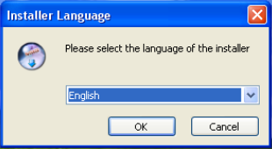

Figure3-1

Step 1: Select the language "English", the Welcome wizard interface, as shown in Figure (3-2) below;

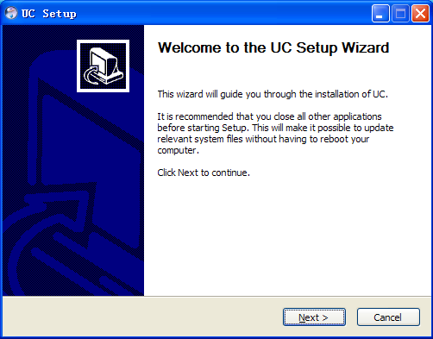

Figure3-2

Step 2: Click "Next", select the installation directory, as shown in Figure (3-3) below;

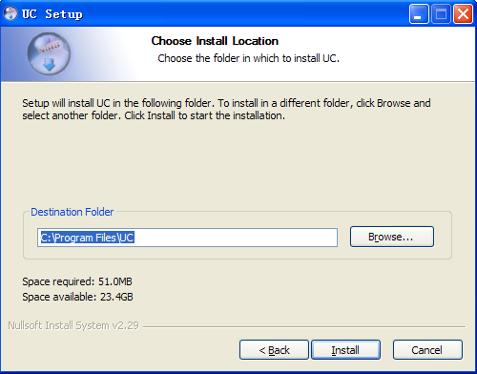

Figure3-3

Step3: Click "Install", the installation is complete appears in Figure (3-4) below;

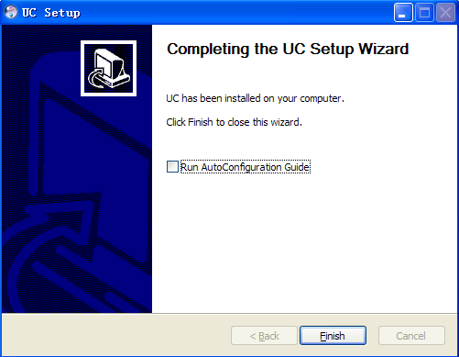

Figure3-4

Step4: Click “Finish” then the installation is finished. The function of “Run UC2” is that the UC2 searches all devices that your computer can connect to; if the device is not in the same network of your computer then its IP will be modified; add all searched devices automatically; after finished the auto-configure, when you login UC2 in the first time, UC2 will play front nine devices automatically. When finished the installation of UC2, this function is not enabled by default.

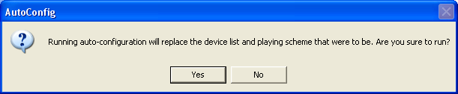

Figure 3-5

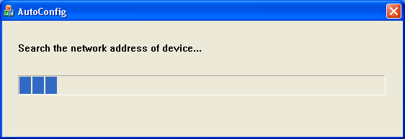

Figure 3-6

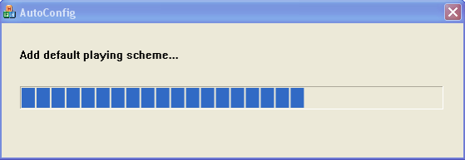

Figure 3-7

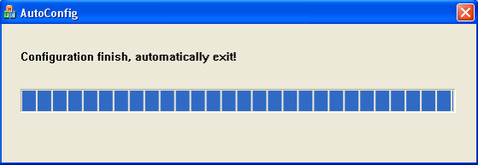

Figure 3-8

### 3.2 Uninstall Steps

Enter start menu "Programs”→”UC”→“Uninstall", operation as follows:

Step 1: Click the "Uninstall" appears to lift interface, as shown in Figure (3-9) below;

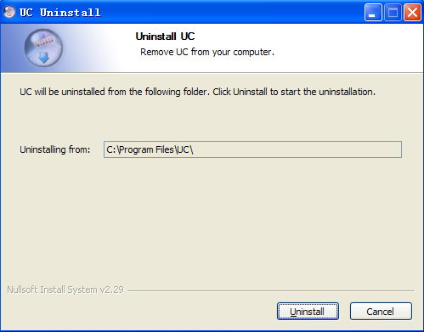

Figure3-9

Step 2: Click the "Uninstall" Uninstall completed, as shown in Figure (3-10) below;

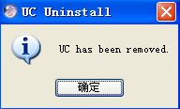

Figure3-10

Step 3: Click "OK" Uninstall completed.

# Chapter4 Config Management

On the desktop, double click **UC** () to start UC login interface. As follow:

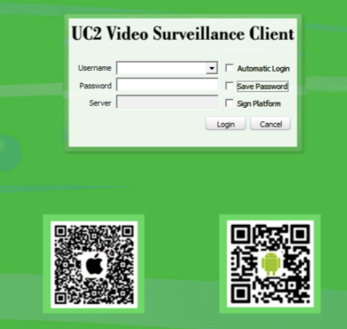

Figure4-1 Login Interface

UC2 Video Surveillance Client login points sign platform and not login two types of landing, Support Qr code scanning to convenice the phone users operation.

When you don’t sign platform, the default username is admin, password is 123456. You can add user after login, the detail operation will describe later. Check "Automatic login", UC will save password and it will login automatically. Check “Save Password” the UC will save the password if you login successfully this time, then you won’t need to enter its password next if you login with this username. In order to ensure the security of the software, if the user checked the "save the password", then in UC exit after login, password a column shows the 32-bit key. UC autosave recently login five user's letter.

When you sign platform, username and password is registered on platform, IP is platform address. Sign platform can only grant access to the user of all the devices automatically, implement preview

video playback, and other functions, can't remote config management P2P devices and add the local device.

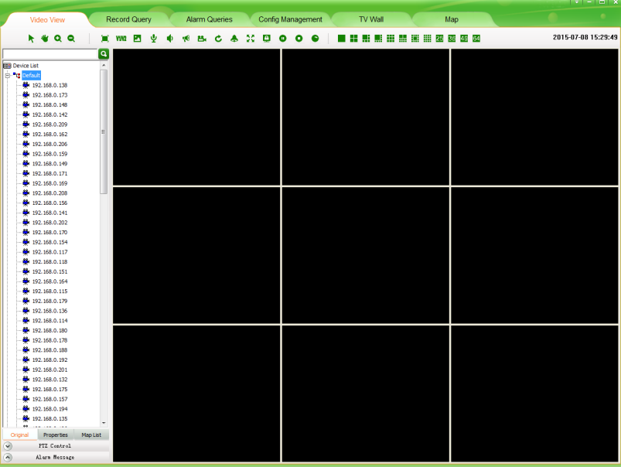

Figure4-2 Main Interface for register the PTZ platform

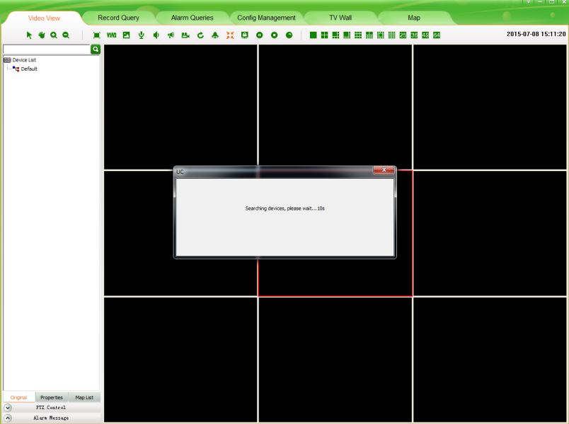

Figure4-3 Main Interface

### 4.1Main Interface description

1. Function menu:

Video View, Record Query, Alarm Message, Config Management, TV Wall, Map, Forward Service Setting, Multi-screen display and Set main functional areas, detailed in Chapter4 Config Management >>; Chapter5 Video View >>; Chapter6 Record Query >>; Chapter7 Alarm Message >>; Chapter8 TV Wall >>; Chapter 9 Map >>; Chapter 10 Forward Service Setting >>; Chapter 11 Multi-screen display >>; Chapter 12 Setting;

1. Video Window:

According to the operation of the toolbar in above, details in “Real-Time monitor” section.

1. PTZ Control:

PTZ control operation details in “PTZ Control” section

1. Device list:

The region display device information, device list details in “Device list” section.

1. Tool Bar:

The video window can do electronic zoom, Dual-stream switch, Capture, Voice talk, Audio, Broadcast, Manual Record, Patrol, Alarm action, Full/Norm, lock screen, Stop, Stop all, start all record, full screen, single screen, 4 screens, 6 screens, 8 screens, 9 screens, 10 screens , 13 screens ,16 screens, 25 screens and 36 screens, 49 screens, 64 screens.

1. Setting:

You can set the software automatic login, boot automatically, system configuration, click the restorable window can restore window, and after restore window can move window, detailed in Chapter 12.

A comprehensive introduction to the various functions as follow (minimum resolution 1024 * 768).

Log in UC, when UC equipment list is empty, add playback devices automatically search.



Figure 4-4 Automatical searching devices

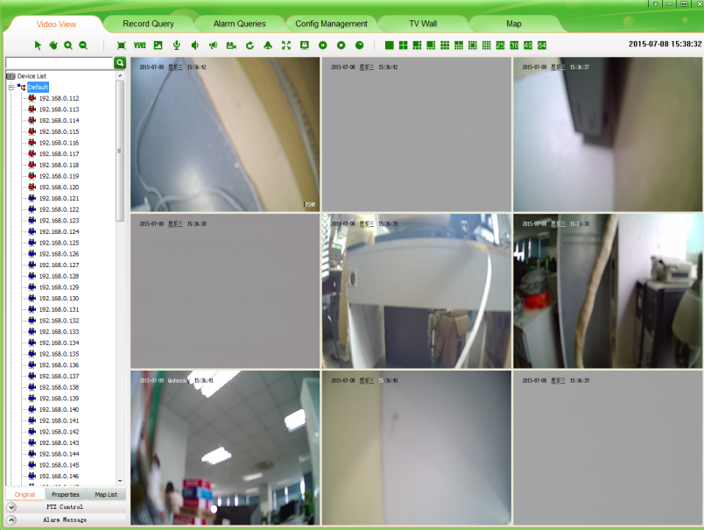

Figure 4-5 Automatical add and play devices

Click the “Config Management” to enter the configuration management interface. There are five main functions: Device config, User config, Record config, Remote config and Maintenance.

Sign platform device config, user config, remote config, maintenance are unavailable.

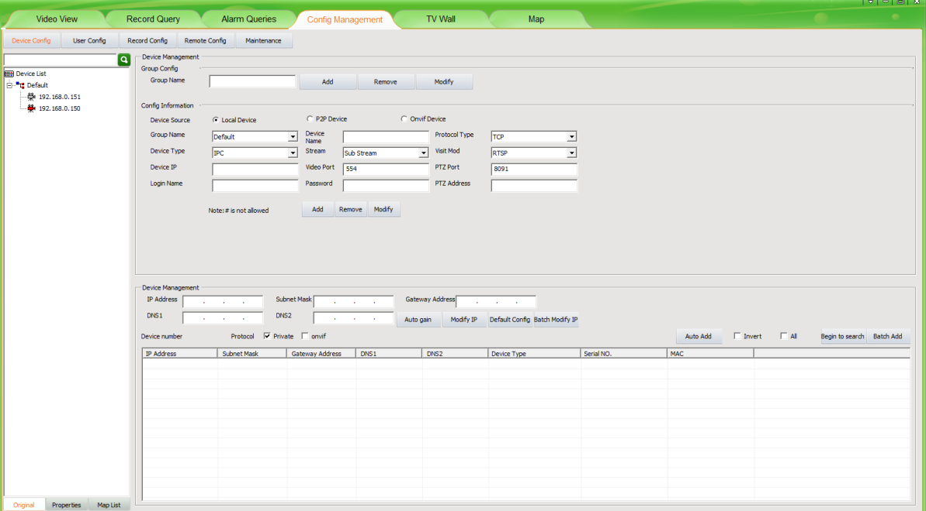

Figure4-6 Config management interface

### 4.2 Device Config

#### 4.2.1 Device Group Config

There is only one group by default. There you can add, remove and modify groups.



Figure4-7 Device group config

1. **Add device group:**

Input the group name, and then click “Add” button. The same device group name is not allowed. The new device group name will be displayed in the device listm, Click the right mouse button can be carried out on the equipment list in ascending order and in descending order, also can delete all.

.

1. **Remove device group:**

First select the device group name to be removed, and then click “Remove”; the cameras of the group will be moved to default group when the group is removed. The default group can’t be removed.

1. **Modify device group:**

First select the device group name to be modified, and then input the new name then click “Modify” button; the same group name is not allowed.

#### 4.2.2 Device Config

##### 1. Add Local device manually:

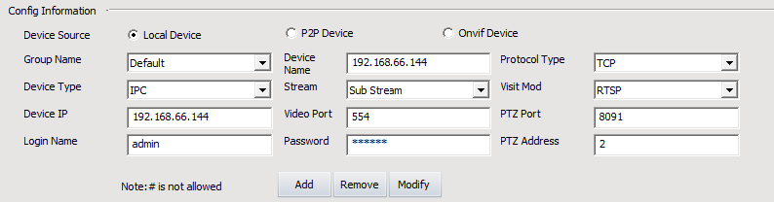

Figure4-8 Device config

First select group name as figure4-5 and device type, input device name, protocol type<accessing Internet recommended TCP>, device type<IPC, DVS, Decoder, Video Switch Server/VSS, NVR/DVR>, stream, access method（The default access method of adding devices is RTSP, you can change the device’s access mode<RTSP or TPS>. The standard method is RTSP; the TPS method is only for the device can’t login IPSAN platform）,device address<it can be IP address or domain name>, video port, PTZ port (IP address, PTZ port and video port must be the same with IPC itself).Login name and password must be the management of the device username and password, PTZ address code and control PTZ address must be the same, otherwise the device will not work properly.

After setting those parameters click the button of “Add”, then you have finished manual-adding new device. Modify and remove device are the same with add device, not repeat.

When Device Type "Video Switch Server/VSS", Device IP for distal open forwarding service host address, and at the same time, also can be the main domain address, "Video Port" for the open service set up the video port. Click on the "add" button, the server device will be added to the left device list.

* **Note:** 1、Add distal device, if it is used to IP address form add will automatic filter out with the same device, if it is used to do main name form will not add to the same device filter.

2、Access UC2 client must use the NVR advice of the company.

##### 2. Add P2P device Manually:

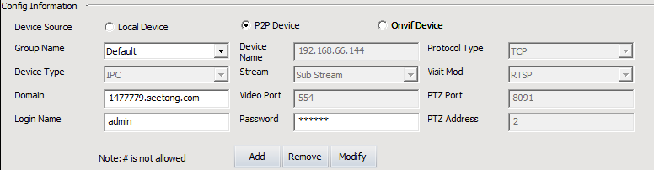

Figure4-9 Add P2P device

Domain is P2P device ID, login name and password for user account and password of the device.

##### 3.Add Onvif device Manually:

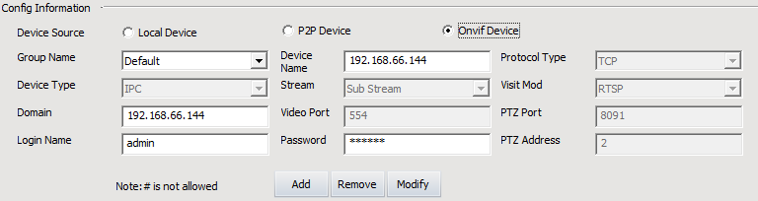

Figure4-10 Add Onvif device

##### Equipment domain for the IP address, login name and password for the equipment user account and password, onvif device does not support changes.

##### 4. Search Local devices automatically:

UC can search local devices the difference between private, onvif equipment automatically.

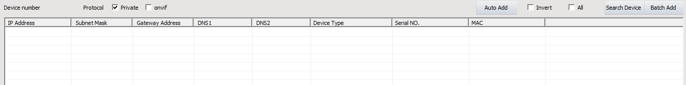

Figure4-11 Search Camera

Click “Search Camera”.UC will search all devices in the same LAN and will display all devices; public network can’t use search function.

* **Note:** 1. If you click the top field in this table, such as IP Address, Subnet Mask and so on, then you can order those searched devices as this field.

2. If you change to other place, the searching will stop.

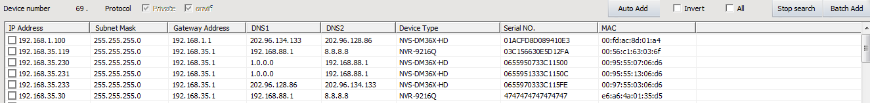

Figure4-12 Search camera

The searching results as Figure 4-12. After your searching, you can double click the” Serial NO.” to copy the device’s serial number.

##### 4.Add device automatically:

Check the device that need to be added to the device list and click “Batch Add”, all the device will be added to the device list.

Check the device and click it, you can modify the IP address, subnet mask, gateway and DNS. Oslo you can click “Auto gain” to get free IP address，Click on the batch modify IP, can be bulk changes to the selected equipment IP.

.



Figure4-13 Modify network parameters

### 4.3 User config

#### 4.3.1 Role config

Role management interface as follow:

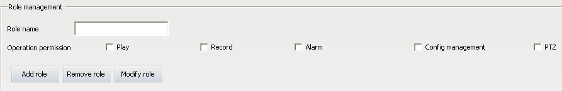

Figure4-14 Role management

There are 5 kind of operation permission: PTZ and Play, Record, Alarm, Log, Config management and advanced operation.

Add role: Input the role name and check permissions then click “Add role”.

Modify role first select role to be modified then the similar with add a role. Select the role in the role list then click “Remove role” to remove it.

* **Note:** All the user groups and users of the role will be removed when remove the role.

#### 4.3.2 User group config

User group management interface as follow:

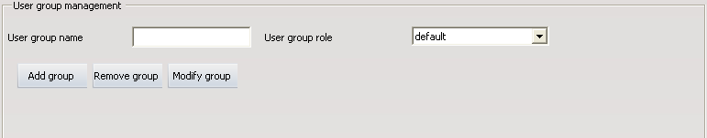

Figure4-15 User group management

Add user group: Input user group name and select the group role then click “Add group”. The same group users are the same user role.

Modify user group first select the user group to be modified then similar with add user group. Select the user group in the user list and click “Remove group” to remove the user group.

* **Note:** The user of the user group will be removed when remove the user group.

#### 4.3.3 User management

User management interface as follow:

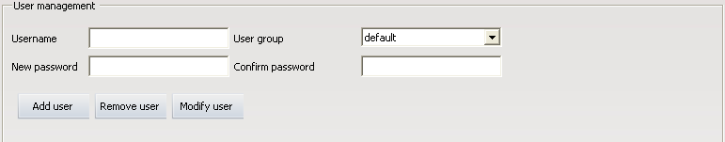

Figure4-16 User management

Add user: Input username, new password, confirm password and select user group then click “Add user”. Do not allow the same username.

Modify user: Select a user in the user list then similar with add a user. Select the user in the user list and click “Remove user” to remove the user.

#### 4.3.4 Rolling Subtitles Management

Rolling subtitles management as follow:

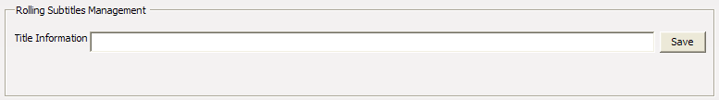

Figure4-17 Rolling subtitles management

Enter the subtitle you want to roll in the text-box of “Title Information”, then click “Save”, words you entered will rolling show in the top of UC. For example, in the “Title Information” write “UC Video Surveillance Client”, rendering as follow. If you need to cancel the rolling subtitles, enter a space in the text-box of “Title Information” and click “Save”.



Figure4-18 Rolling captions rendering

* **Note:** Because the resolution of 1024 by 768 is lower, it will make the space of whole interface not enough, the set rolling subtitles will affect the button area under. So suggest you choose the resolution of 1280 by 960.

### 4.4 Record Config

#### 4.4.1 Record strategy

Record management interface as follow:

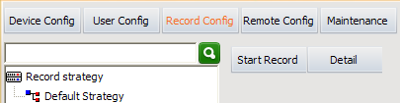

Figure4-19 Record config

In the 【 Device Config 】 interface to add the device, UC2 will put device into "Default Strategy". Later add device also will be added to the "Default Strategy". "Default Strategy" configuration is the Strategy of the device for 24 hours timing video. In the【 Record Config 】 interface click "Start Record", will start the Record strategy. Start Record button into a "Stop Record", and click the button, then stop the Record strategy. If you have multiple record strategy, click【 Video View】interface in the toolbar "Start All Record" button.

Click “Detail” button you can view the detail information of default strategy.

#### 4.4.2 Strategy config

Click “Detail” then enter the interface of record strategy detail configuration. As figure 4-20:

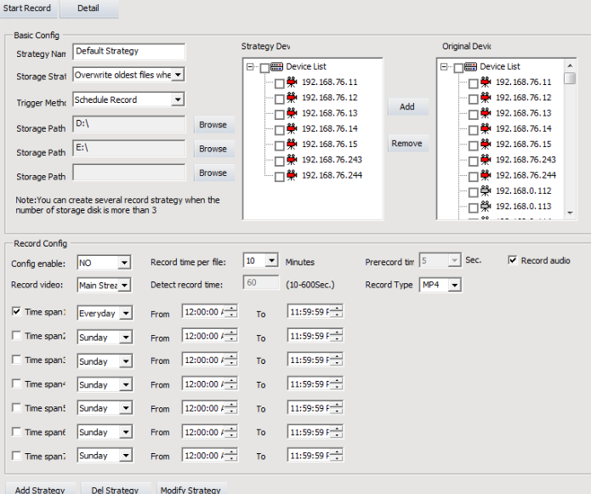

Figure 4-20 Record parameter configure interface

The configuration of record strategy includes two sides: Basic Config and Record Config. Next we will have a detailed explain for every parameter.

Strategy name: There is a system default named Default Strategy, which can not modify. When you need add other strategy, you can named by yourself but Default Strategy.

Storage Strategy: You have two choices, Stop record when full or Overwrite latest files when full.

Trigger method: Schedule Record refers to record all the time during the time you have set; Motion detect Record refers to when has motion alarm then record, the premise is that the device has already opened motion alarm; IO alarm record refers to when has IO alarm then record, the premise is that the device has already opened IO alarm strategy path: The system will auto gain three disks as strategy, except your system disk. When user need modify the strategy path can click the button of “Browse” to select path free. When user need delete the strategy path,, click “Browse”, then click “Cancel” on the pop-up dialog box.

Original devices: All devices that you have added.

Strategy Devices: Devices in current record strategy. Modify record device you can by those buttons between “Original devices” and “Strategy devices”

Config enable: When user choose yes and save, then open current record. Strategy record can also opened by clicking the button of “start record”. When user choose no and save, then close current record.

Record time per file: Record time for a schedule record.

Prerecord time: The time before start record.

Record video: User can choose sub stream or main stream.

Detect record time: Record time for a motion detect record.

Record audio: If hope the record file with audio you need choose it. Only when device encode audio and checked it then the record file will be video and audio file.

Video type: select video format video files, can be set up MP4 format and AVI format.

Time slot set: It refers to set the record time, you can set seven time slots total. When there be some conflict during different time slot, the system will automatically take there intersection. After starting record, there will be video file only in the time slot.

Add strategy: When different device needs record in different trigger method, or when devices are many, suggest you to configure more than one record strategy. Choose devices, configure the store path and other parameters, click the button of “Add Strategy” then create a new strategy. There are four record strategies in figure 4-20. If the record strategy is not default strategy, you can only enable it by the button of “Config Enable”, choose yes means start record, choose no means finish record.

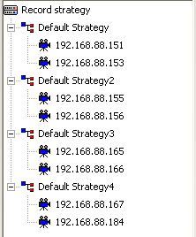

Figure 4-21 Added four record strategies

Delete strategy: click the record strategy name on the left device list, related configuration information for this strategy will detail show on the right. Click the button of “Del strategy” will delete this record strategy.

Modify strategy: If you have modified some parameters for strategy, you need to click the button of “Modify strategy” to ensure it

### 4.5 Remote Config

#### 4.5.1 Select device

Click the device that must be online in the device list.

#### 4.5.2 Remote config

The interface device is not selected as follow:

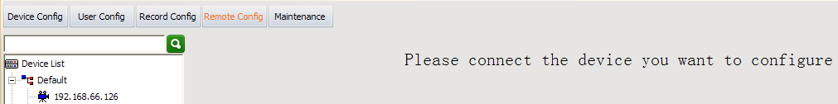

Figure4-22 Remote config interface

After select a device:

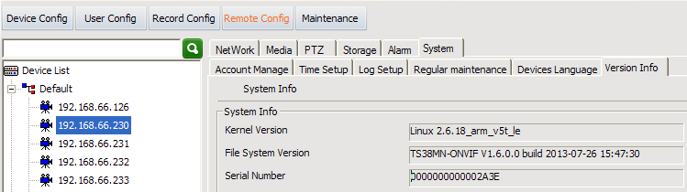

Figure4-23 Remote config

You can refer to IPC instructions to modify network setup, media setup, alarm setup and so on.

* **Note:** Remote config is not allows for DVS、Forwarding UC2 client device.

### 4.6 Maintenance

#### 4.6.1 Device information list

Device information list is to check devices do below operating. Before device upgrading, configure file uploading or downloading, rebooting, restoring, you must check devices first then you can do those operating to them. The device information list only include online devices, during operating (such as reboot) the device must offline for a moment, then you will see the device out of the list and come out in the top of the list some minutes later.

#### 4.6.2 Upgrade

Checked need to upgrade device, click on the "browse" button, the local computer to find upgrade file the folder, select the corresponding device types of firmware program, and click "update", namely start remote upgrade. If the upgrade failed, please try again.

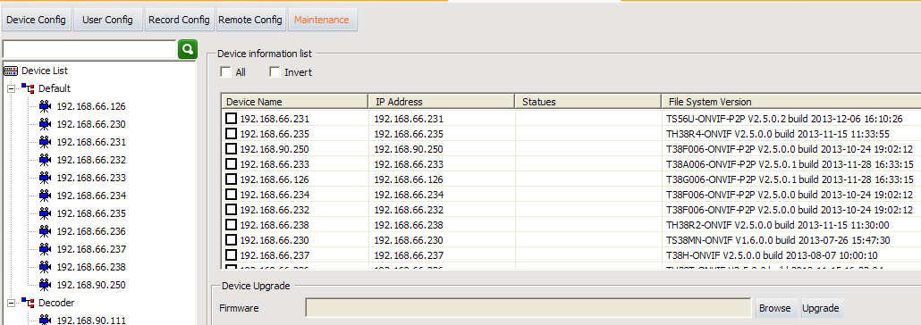

Figure4-24 Upgrade

#### 4.6.3 Config file Upload and Download

Upload config file: first click “Browse” to select the correct config file and check the devices to be uploaded, then click “Upload”.

Download config file: first click “Browse” to select directory for saving cinfig file and check device that download config file from, then click “Download”.

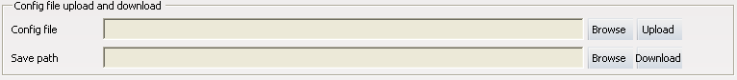

Figure4-25 Config file Upload and Download

#### 4.6.4 Reboot, Default Config and Sync system time

Check devices and click “Reboot” to reboot the devices.

Check devices and click “Default Config” to restored the devices.

Check devices and click “Sync system time” to modify devices time.



Figure4-26reboot, default config and sync system time

#### 4.6.5 The management of front-end storage device

After choosing the device, click “Format”, then the TF card or USB device will be formatted.

After choosing the device, click “Uninstall”, then the TF card or USB device will be uninstalled.

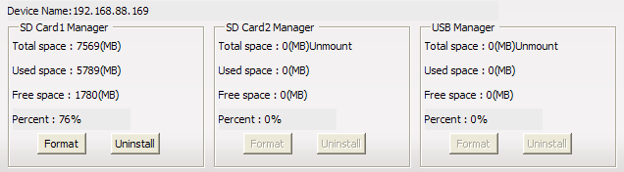

Figure4-27 The management of front-end storage device

# Chapter5 Video View

After adding and configuring devices, click “Video View”, then skip to video view interface, here you can watch the real-time video.

#### 5.1.1 Real-Time Monitor

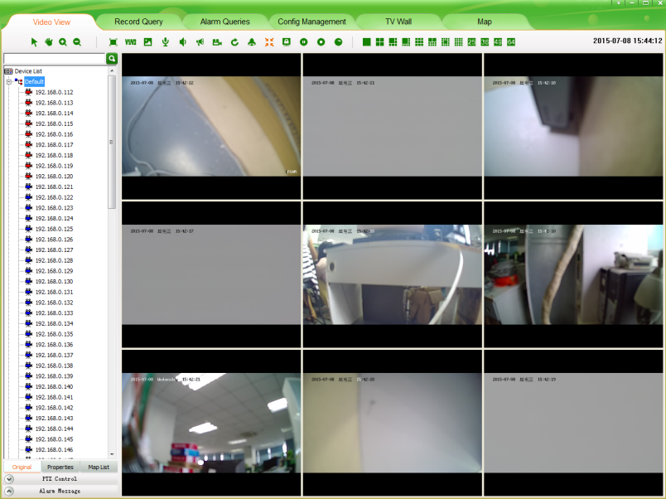

Figure5-1 Surveillance interface

* Note: 1. Two or more play window is when view playing, Select a window and click continued one second, until a red camera sign come out, then drag to another window, those two windows will exchange their video.

2. Video window supports the function of right-click mouse, The function of it is the same as the function of buttons in the video surveillance tool bar, detail operation will be described follow.

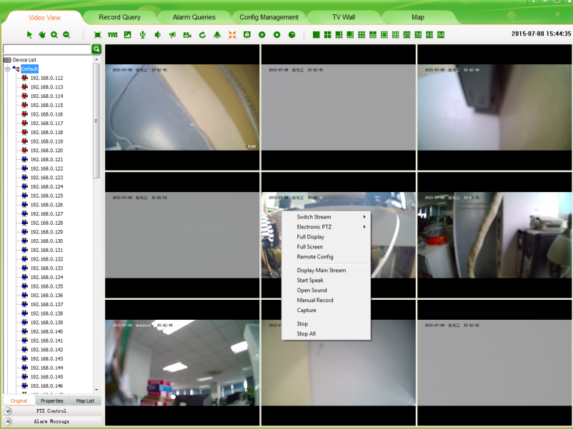

Figure5-2 right-click menu function

#### 5.1.2 Real-Time Monitor Method

Select and drag a device to the focus video window that will display real-time video of the device.

Select and double click a device, if the focus window is empty, it will display real-time video of the device; if the focus is playing, system will search empty window from focus window to display real-time video of the device.

Select and right-click a device group name, then you can choose “auto play this group’s devices”.

#### 5.1.3 Electronic zoom

This is electronic zoom function. There are four buttons in electronic zoom function area. They are Pointer, Moving, Zoom Out and Zoom In.



Figure 5-3 Electronic zoom function button

 Zoom In: Preview condition, in the toolbar after click this button, there are three methods to enlarge video screen:

Drag mouse to the window that you need to enlarge, the mouse turns to . This time click the video screen, system will enlarge the video screen with current point as the center.

Drag mouse to the window that you need to enlarge, up roll the mouse wheel, current video screen will enlarge show.

Drag mouse to the window that you need to enlarge, click somewhere then drag mouse without releasing it. Then come out a red box, release the mouse as you need, video screen enlarge show.

 Zoom Out: After the video screen enlarged, click this button and drag mouse to enlarged window, then mouse turns to . This time click mouse, video screen narrow show. You can down roll the mouse wheel to narrow the video screen too.

 Moving: After the video screen enlarged, click this button and drag mouse to enlarged window, then mouse turns to . This time drag mouse you can drag the enlarged video screen.

 Pointer: After the video screen enlarged, click this button, the video screen will regain normal size to show. If there are many devices enlarged, click it will regain all.

#### 5.1.4 Dual-stream Switching

Due to network bandwidth limitations and the requirements of high-definition video, IPC and other front-end device using dual-stream technology which can encode two completely different bit stream (including a different resolution, frame rate, quality) at the same time. Main Stream used for local real-time storage, Sub stream used for remote network transmission. Thus take into account the image of high quality local storage requirements and long-range low-bandwidth network transmission of images fluency requirements, to break through network bottlenecks and maintain Endowment effect of the local HD storage.

In the video surveillance tool bar, click "V1/V2" button on the focus of the video window to switch the video stream. If need to screen amplification not automatic switching main-stream, then see Chapter12.5 Switch Stream Setting.



Figure5-4 Dual-stream switch

#### 5.1.5 Capture

In the video surveillance tool bar, click on “Capture” button on the focus of the video capture video window. The default storage path of local record is in the “Picture” directory that under the file of theinstallation program, if you want to change the storage path please turn to Chapter12.3 Storage setting.



Figure5-5 Capture

#### 5.1.6 Voice Talk

In the video surveillance tool bar, click on the “Voice talk” button in the video window with the focus on real-time front-end device features two-way voice talk. When the voice talking is turned on, the user switch the focus window will make no difference with it. And the status bar under the video window will show current voice talk status.



Figure5-6 Voice talk

#### 5.1.7 Audio Switch

In the video surveillance tool bar, click on the "Voice” button, you can open or close the focus of the audio video stream monitoring. When the sound is turned on, the user can switch the focus to follow the audio window to switch the focus of the window. And the status bar under the video window will show current voice status.



Figure5-7 Audio

#### 5.1.8 Broadcast Audio

Broadcast Audio realization must first configuration broadcast audio encoding format and need to broadcast device, the specific configuration method and process see Chapter12.6 Boradcast Set.

For device set up after the broadcast, in the video toolbar and click  button, the button into, device into the broadcast state. If you want to stop broadcast again, click on the "Broadcast Audio" button.



Figure5-8 Broadcast Audio

Because NVR only support audio coding format for G711 broadcast, so UC2 and NVR broadcasting, in 【 Setting 】-【 Broadcast Set 】 select any channel NVR in G711 coding format can be add to the list of radio device in【 Video View 】interface to the NVR broadcasting operations

#### 5.1.9 Start to select the fragment of device record

In the video surveillance tool bar, click the “Start to select the fragment of device record” button, the focus of the video window will start record. The same time the button changes from  to . Button  always represent that the device is recording, and if you want to stop record please click the button . Once manual record the longest time is 30 minutes, 30 minutes later the system will cut down current record and start a new record. The default storage path of manual record is in the “Video” directory that under the file of theinstallation program, if you want to change the storage path please turn to Chapter12.3 Storage setting.



Figure5-9 Start to select the fragment of device record

#### 5.1.10 Patrol

Start patrol you must configure patrol for video window first, the detailed configure method and process will be explained in Chapter12.4 Patrol Setting.

After configured patrol for window, Click the button  in the video surveillance tool bar, then button turns to , the window is patrolling. During patrolling the button of “dual-stream switch”; “local record”; “voice talk”; “voice” can’t use. If want to stop patrolling re-click the “patrol” button, then this window will play the real-time video streaming of the stop-time device. This moment that four buttons can’t use still.



Figure5-10 Patrol

#### 5.1.11 Alarm Linkage

Alarm linkage: enable it. When UC receives alarm, it wills response to the alarm in different ways. Three methods of alarm linkage: No1. Tree node flash (as figure 5-12).No2.Play alarm sounds. Different sounds of master device and camera.No3.pop video window and play video. If there are many devices alarming, it will play video of the first alarm. In the alarm list (as figure 5-13).Red alarm information means the alarm not processed, black alarm information means the alarm already processed. Click the “Begin speak” button, voice talk is opened.



Figure5-11 Alarm linkage

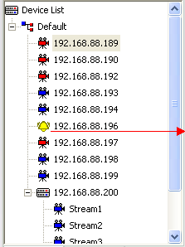

Alarm linkage

Tree node flash

Figure5-12 Tree node flash

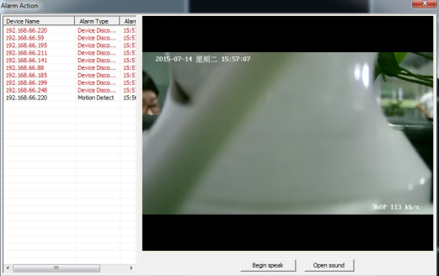

Figure5-13 Alarm linkage window

#### 5.1.12 Full and Norm

In the video surveillance tool bar, click on “Full/Norm”, the real-time video will full-screen display. The default screen is standard screen; twice click the button to return. It will save and recover playing mode automatically after exit and re-login.



Figure5-14 Full and Norm

#### 5.1.13 Screen Lock and Unlock

In the video surveillance tool bar, click the "lock screen” button, then all UC operating screen will be locked. This moment, you can do nothing but watch the video streaming. And the button appears to  if you want to exit this status, click it. Then an input-box pops and you must input your username and password to success unlock.朗读显示对应的拉丁字符的拼音



Figure5-15 Lock screen

#### 5.1.14 Stop Video

In the video surveillance tool bar, click "Stop" button to stop the current the real-time stream of the focus window. Click "Stop all" button to stop all real-time video.



Figure5-16 Stop video

#### 5.1.15 Start all record

Enter the interface of [Config Management] – [Record Config], right configured the record strategy you need. Then return to the interface of [Video View], click the button of “Start all records”, all records strategy will be opened. This button is a shortcut button for strategy record.



Figure5-17 Start all records

#### 5.1.16 Full-screen Control

In the video surveillance tool bar, click on the corresponding split-screen button to switch to a different monitor screen, 1 screen, 4 screens, 6 screens, 8 screens, 9 screens, 16 screens, 25 screens, 36 screens, 49 screens, 64 screens. Click on "Full screen" button will present a single screen or multi-screen to full screen. Click "Esc" button to exit full-screen



Figure5-18 Full screen

#### 5.1.17 Device List

* 1. There are two ways the device list display: “Original” group(Figure 5-19 left) and "Properties" group (Figure 5-19 right):
     1. "Original group" is the device group name +device belongs to the device group as the node to display
     2. "Properties group" off-line devices and on-line devices are shown separately.

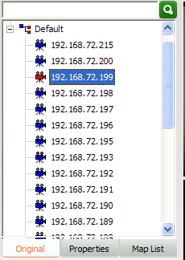 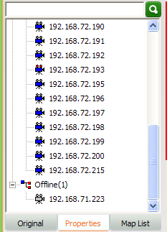

Figure5-19 Device list tree

* 1. There are several leaf node icon, “blue” present the device is online, “gray” present the device is offline, “red” present the device is play video; Two small red points present the device is recording.

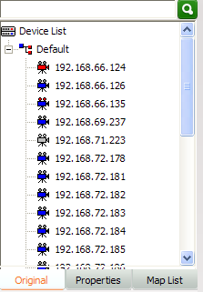

Offline devices

Online devices

Playing video devices

Recording devices

Figure5-20 Device status

#### 5.1.18 PTZ control

1. **PTZ control method**

There are two PTZ control methods: Interface control, joystick control.

1. PTZ control interface: In PTZ control, top window activity. you can operate PTZ such an up, down, left, right, adjust the iris, adjust the focus, adjust the zoom, perform preset, configure preset、timed period of place, time period of patrol,the linear sweep as well as advanced features such as call; up, down, left, right, iris, focus, zoom control in the corresponding function key on the left began to hold, release the left mouse button to stop. Directional control can adjust horizontal velocity and vertical velocity control; preset point and advanced features of the control rules refer to the “**PTZ advanced function**”

~~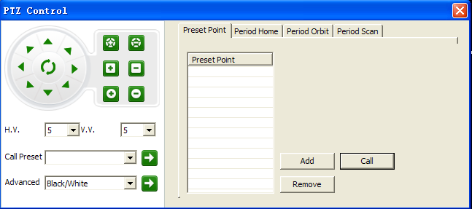~~

Figure5-21 PTZ control

1. Joystick Control: PTZ control keyboard access to the specified PC keyboard for use in accordance with the corresponding parameters. client-side under the keyboard also need to set the parameters corresponding to the configuration, the user clicks on the main interface of buttons popup menu select "System Configuration" – “Joystick”, In the " Joystick" interface configuration corresponding parameters can be preserved. Configuration is completed the user can use the keyboard to the corresponding PTZ control.

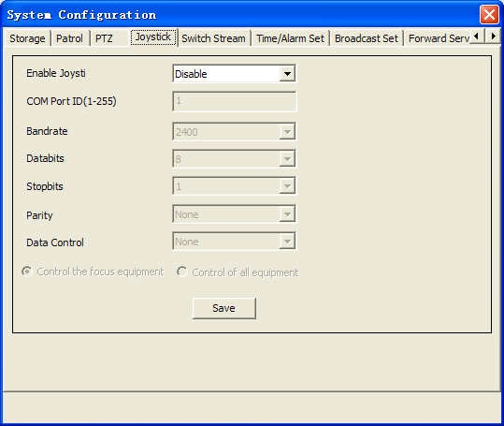

Figure5-22 PTZ joystick control

1. PTZ Protocol Control: Control of if PTZ device support custom PTZ control protocol control, the user clicks on the main interface of buttons popup menu select "System Configuration" – “PTZ”, in the “PTZ” interface select PTZ protocol , after the completion of the user configuration can be used in the preview interface PTZ control panel for the corresponding PTZ control.

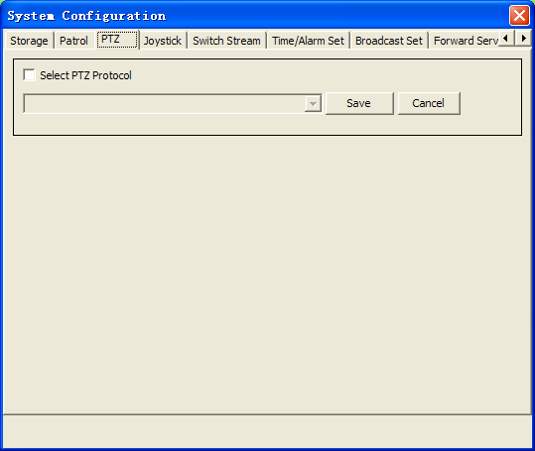

Figure5-23 PTZ Protocol

1. **PTZ advanced function**
2. Preset point:

Click up、down、left and right of the PTZ Control, each location set one preset point to add a point. Has increased the preset point, can be selected to a preset point, and then click the "call", the device will turn to change a preset position, click "delete" is to remove the preset point.

2) Timing homing:

1. Set the start time and end time, click add to generate a time period. Such as 1#01:00-01:59, means from 1 o’clock to 2 o’clock, if you had set timing scan during this time, then the device will back to the preset every five minutes and stay for one minute. “1#” means first one, you can set eight in total.
2. Start time and end time choosing between 00:00 to 23:59, start time is greater than end time ,Every day you can only set eight timing homing.
3. Show the time period, Click delete to delete.

3) Timing orbit

1. Set the start time and end time, click add to generate a time period. Such as s1#01:00-01:59, means from 1 o’clock to 2 o’clock orbit all the time.
2. Start time and end time choosing between 00:00 to 23:59, start time is greater than end time Every day you can only set eight timing orbits.
3. Show the time period, and it will show in “remove preset” ,Click on the “call” , you can call in advance the time , click stop to stop touring, click delete, delete the place of the time period”.
4. Timing scan

a) First, Set the Sweep line starting point and line sweep end. Set the start time and end time, click add to generate a time period. Such as s1#01:00-01:59, means from 1 o’clock to 2 o’clock orbit all the time.

* 1. Every day you can only set eight timing scans.
  2. Show the time period, and it will show in “remove preset”.

1. Notice:
2. The time can not cross between “timing scan” and ”timing orbit”.
3. The time can cross between “timing homing” and ”timing scan” or “timing homing” and ”timing orbit”.
4. If “timing homing” and ”timing scan” have time cross then “timing homing” first. the same as “timing orbit”.
5. Nobody control the PTZ for six minutes later then begin “timing scan”, ”timing orbit”, ”timing homing”.
6. “Timing homing” stay for one minute.
7. The value you set accurate to the minute.

#### 5.1.19 Alarm Message

When the client receives the alarm information in real time the main interface of the "Alarm Message" will be flashing, the user clicks the "Alarm Message" button to view real-time alarm information screen. The interface for the alarm information to show the 16 records dynamically updated. Alarms for query previous see instructions of "Alarm Query ".

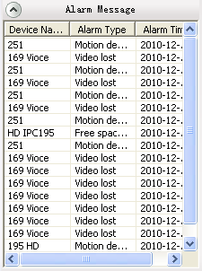

Figure5-24 Real-time alarm

# Chapter6 Record Query

Click the "Record query" menu and go to the record query interface. Record query pages include file playback and time playback. File playback include local record query, record playback and front-end record query, record playback, record download, Time playback support local record four-screen sync playback(64 - bit Windows 7 support 9,16 screen playback at the same time),

32-bit Windows 7 as follow:

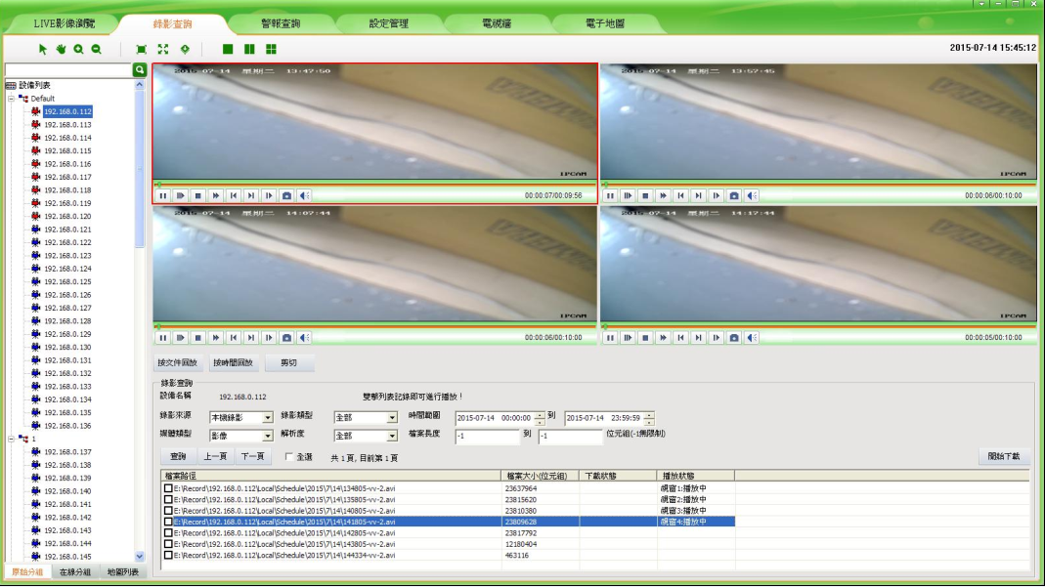

Figure6-1 File playback

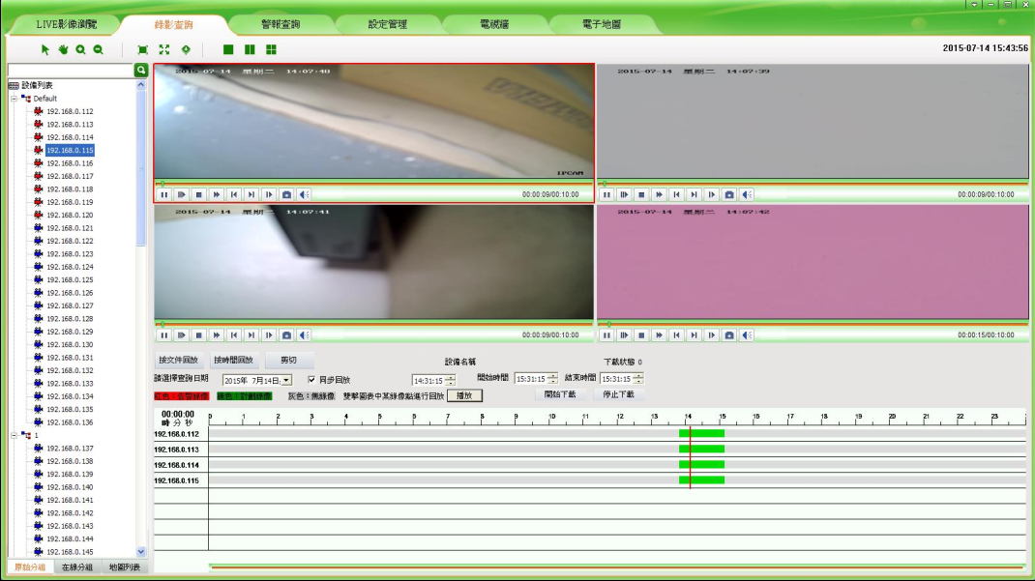

Figure6-2 Time playback

### 6.1 Video Query

#### 6.1.1 File playback

Select a device that queried in the device list and set the conditions, then click "Query" button. Record source include "Local Record" and "Front-end Record". Local Record select a different record sources are not the same type of the corresponding record resolution. 20 records per page, you can click the “Pre page” or "Next page" to view more, Front-end Record display only one page.

#### 6.1.2 Time playback

User in the time frame to select the desired inquires the video time, click on the device to the list of device name, can show inquire the record.

Every time a 64 - bit system can display 18 equipment query result (32-bit system every eight devices can display the query results), click again on the query results will eliminate the earliest.

### 6.2 Play back

#### 6.2.1 Local Record Playback

Entering [Config Management]-[Record Config], configuring the record strategy and starting record, in this way you can get local record. Local record files saved in local computer. In file playback interface double click one of the searched video then it will play in playback window. You can playback four records at the same time; In time playback interface double click the query result can replay a equipment a video of the time, you can playback four-screen records at the same time. In the playback window, your can operate the tool bar below to pause/play, frame forward, stop, fast forward, previous section, next section, slow forward, taking picture, sound and so on. The default storage path of taking picture is in the “Picture” directory that under the file of the installation program, if you want to change the storage path please turn to Chanpter12.3 Storage setting.

* **Note:** 1. If device is not video strategy, file playback can't search local video file, time playback retrieval local video file for grey.

2. Fragment of device record files can't be retrieval.

3. During replaying video, you can use electronic zoom function too. The use method of every button is the same as Video View, now we will not repeat again.

4. Device type for the NVR local video can only be in the "File playback" according to the document query and playback.

5. NVR native video can only be in the "Time playback" according to time query and playback.

#### 6.2.2 Front-end Record Playback

Front-end device with storage device, configured record strategy and started record, in this way you can get front-end record. Double click one of the searched video then it will play in playback window. One device can only play one video file in the same time. In the playback window, your can operate the tool bar below to pause/play, frame forward, stop, fast forward, previous section, next section, slow forward, taking picture, sound and so on. The default storage path of taking picture is in the “Picture” directory that under the file of theinstallation program, if you want to change the storage path please turn to Chapter12.3 Storage setting.

### 6.3 Download Front-end Record

Local record saved in your computer so you needn’t download it. The record download is front-end record download. If you want to download the records accord to file playback, simply "Check" the record and then click the "Download" button. According to time playback query as shown in figure 6 -3, click the needed devices in the equipment list after choose the query date, query display the corresponding video type, set up the start time and end time, click "start download" button to download. Record of the default storage path is the default storage strategy path “Remotion”. Users who want to stop downloading click the "Cancel" button.

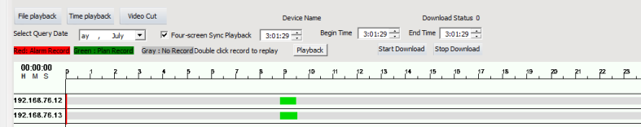

Figure 6-3 Time playback query to download video

**Note:1、 Accord file playback** download the video cannot be other operations of the menu items，But time playback download the video only cannot be playback video.

2、The file of playbacking record can not be downloaded

### 6.4 Video Cut

Video shear cut the local video in avi format video files into smaller files.As shown in figure 6-4 add Local video files in the source file path, the output file after clipping the preservation of the path for the default storage strategy path next to the corresponding equipment name folder in the” Local”, the user can through the button to change the output directory path, set video cutting time, pay attention to end time is not greater than the file time, after the Settings, click the “Video Cut” button, prompt to complete.

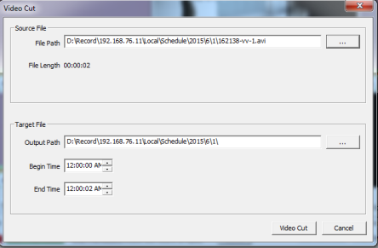

Figure 6-4 Video Cut

# Chapter 7 Alarm Message

Click the "Alarm Message" then enter the alarm query interface.

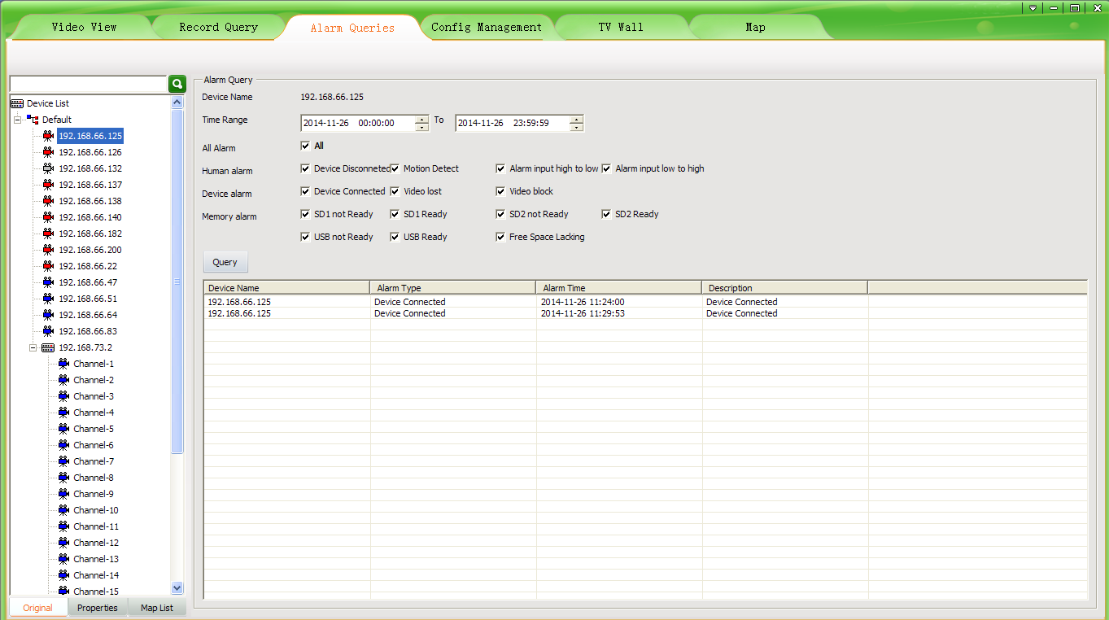

Figure7-1 Alarm Inquires

First select the device in the device list, then set the queried conditions and click the "Query" button to check out the device in this period of time alarm type of alarm occurs.

* **Note:** It will keep the alarm message of a week.

# Chapter 8 TV Wall

Click “TV Wall” then skip to TV wall interface. Only the “admin” user has access authority, to others UC will prompt that “without TV Wall management permission”.

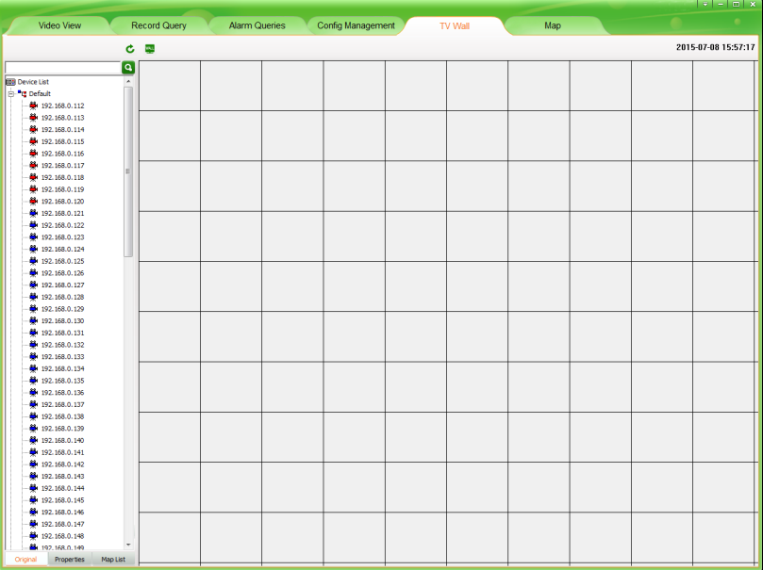

Figure 8-1 TV Wall interface

## 8.1 TV Wall layout

In the TV Wall interface, left is a device list, the function of this list is almost the same that mentioned in 5.1.11, the difference is that this device list includes decoder device. Right is monitor layout area, in this area you can overall layout for your monitor.

## 8.2 Monitor layout

There is a button in the top of monitor layout area,  named TV Wall layout, clicking it then come out the TV Wall layout setting window. In this window you can set the number of Horizontal lines and Vertical lines, the setting range from 1 to 20. After setting, clicking the “save” button then the monitor layout area will layout as your setting. If you don’t set it will layout in default setting that means horizontal line is ten and vertical line is ten too. When the decoder device is many, suggest you to set a bigger number.

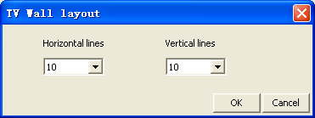

Figure8-2 TV Wall layout setting

After the TV Wall layout, you can press the left mouse button and drag to down or right or right-down in any area of monitor layout area grid. This way you can draw out the window of monitor. According to different number of decoders you can draw different number of windows. Clicking the right mouse button in a drawn window area you can delete this window.

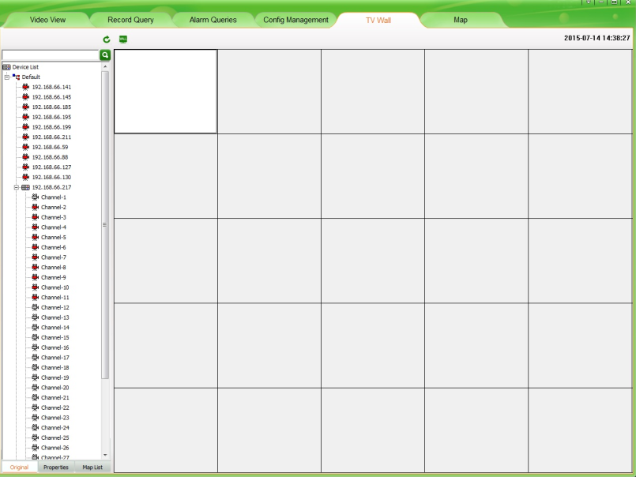

Figure8-3 Monitor layout Configure

## 8.3 The binding of decoder and monitor

After layout the TV Wall and monitor, first, connect the video-out line of decoder and the video-in line of monitor or TV; then drag a decoder to the good layout monitor window. The window will become black, this moment the software has connected decoder and the decoder window shows the connected decoder device IP. Then drag an IPC or NVS or other device to this window, the window becomes yellow, the decoder begins decoding the connected device’s video and decoder window shows the connected encoder device IP . This moment the monitor begins to play the real-time video of IPC or NVS and so on. During decoding you can change the device by dragging other devices to decoder window.

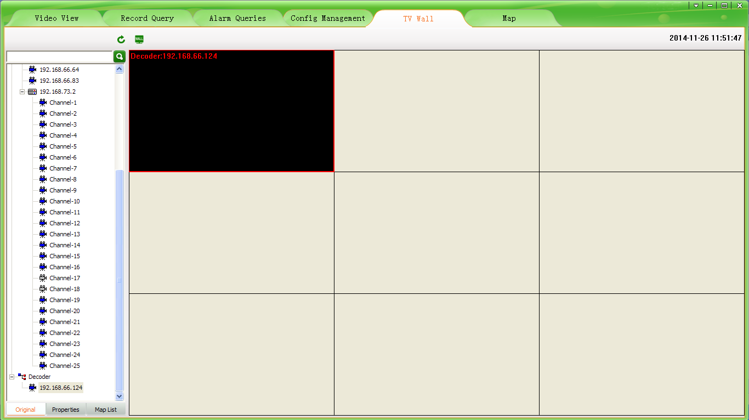

Figure8-4 Decoder binding

## 8.4 TV Wall patrol setting

Decoder support device’s patrol. Click thebutton, popup menu select "System Configuration" - "Patrol", in the "Patrol" interface choose "TV Patrol".

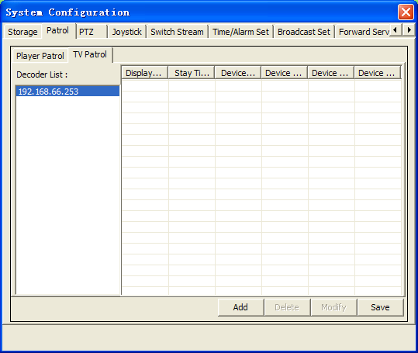

Figure8-5 TV wall in turns setting

In “TV Patrol”, left is decoder list, UC will display all decoder devices in this list by searching from device list automatically. Right is the show area of patrol setting. There are four buttons in the bottom of “Patrol setting”, “Add”; “Delete”; “Modify”; “Save”.

Clicking “Add”, come out “Add Patrol” dialog. Decoder can choose "Display one video" or "Display four video"; Multidecoder can choose " Display one video ", " Display four video ", " Display nine video " or " Display sixteen video "; the “Stay Time” can’t less than 10s; click a device that in the left device list, then it will show in the right column named “Video*”, At the same time can choose to the resolution of the decoding device. After that, click “Add” then you have added a device for patrol successfully. By this way, you can add other devices. A decoder patrol you can add ten devices at most (a multi-screen display is looks as one device). After you added you must click the “Save” button then your setting is effective.

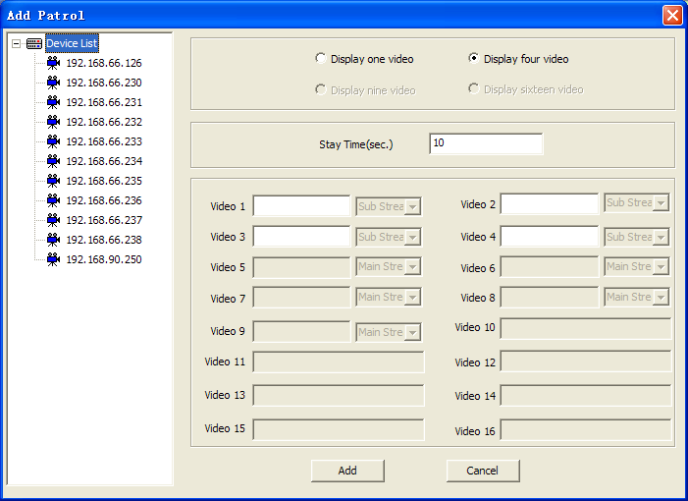

Figure8-6 Decoder to add patrol

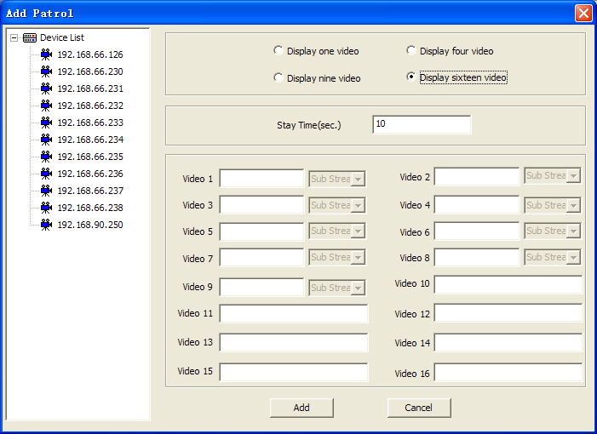

Figure8-7 Multidecoder to add patrol

Clicking “Delete”, you can delete the device of patrol. First choose the decoder that you want to delete its device, second choose the device that you want to delete, third click “Delete” button. After you deleted you must click the “Save” button then your setting is effective.

Clicking “Modify”, you can modify the device of patrol. Choose the decoder, then choose the device, click “Modify” button, come out “Modify Patrol” dialog. You can modify the screen display; stay time or device. After that, click “Modify” then you exit modify dialog, but this time your modification has no effect, only when you click the “Save” button then your setting is effective.

After you configuring device’s patrol, exit the “TV Patrol” dialog, draw a window in monitor layout area, drag a decoder device to the window, click the “Patrol” button, the monitor will begin to play patrol video. You can also start patrol when the monitor is playing real-time video. Click again the “Patrol” button, you can end the patrol. After the patrol is ending, the decoder end decoding, the monitor display nothing.

* **Note:** Under the TV Wall, when there is one device the decoder decode main stream.

# Chapter 9 Electronic Map

Click on the "map" menu, jump to electronic map interface. The electronic map is a specialized custom function, convenient user to layout and locate device. After added the map, according the actual location of devices, drag devices to the position on map, then you can monitor devices.

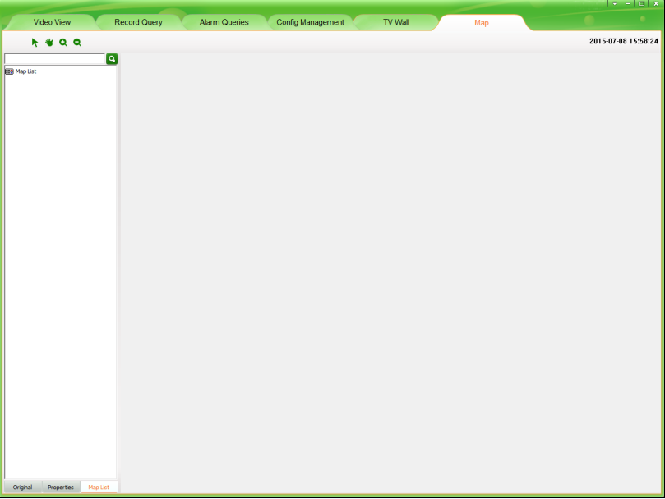

Figure 9-1 map interface

## 9.1 Electronic map layout

In electronic map function module, left is device list, the function of this list is almost the same that mentioned in 5.1.11, the difference is that there is a list called map-list. The map-list is to show the name of added map. Right is map show area, here you can add map, sub map and devices.

#### 9.1.1 Add map

In the map shows area click the right button of mouse, choose “add map” in the drop-down menu, then come out a window to enter some information, as figure 9-2. “Map name” means the name of the map you need to add. “Map file” means you need browser your computer to choose the map that you need to add in. After you set, click the button of “Add” then the map you added will show in the area of map-show-area, at the same time the map name will show in the map list.

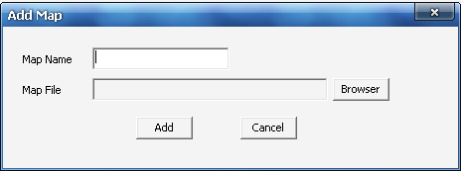

Figure 9-2 Add Map

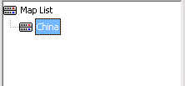

Figure 9-3 Map List

#### 9.1.2 Add Sub Map

Sub map is the detail show for some area of map. When the map you added is very big and some area are not detail, you can add a sub map in this area. The way to add sub map is similar to the way to add map, the difference is that before you add sub map you need select the place to add it. Where you select where will be a sub map. After you added success, there is an icon in the map, click it then you can enter sub map.

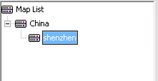

Figure 9-4 Map List

Note: If you add no map, the option of "add sub map" is not available. A map can add more than one sub map. The format of the map must be .jpg.

#### 9.1.3 Add Devices

You can add device into map and sub map. Select the map, click “Original” or “Properties” in the left device list, then select the device you need, drag it to the target position on map, after that release the mouse, then you add device success. After added devices success, you will see an icon and the device’s IP on map.

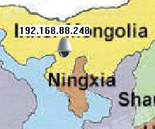

Figure 9-5 Devices Add Success

**Note**: A device can not add for many times, but a map can add more devices.

## 9.2 Play devices video

#### 9.2.1 Real-Time Monitor

When you need monitor a device, click the device icon on the map, then will come out a video play window. Now you can by the right-mouse-function do some operation such as video play, stream switch, voice talk, capture, manual record and so on.

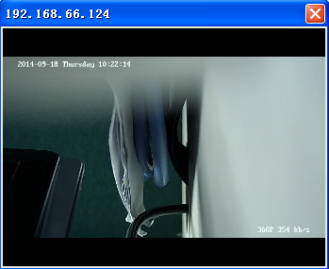

Figure 9-6 Video window

**Note**: Video window supports the function of right-click-mouse. The function of it is the same as the function of buttons in the video surveillance tool bar, we will not description again.

#### 9.2.2 Full screen/exit full play

Double-click the video window, video will full display, double-click again, then exit full display. When in full display, the function of right-mouse can also be used.

#### 9.2.3 Devices video change

On the map, click the device icon you can open its video, this time click another device icon the video will change, in this way you can choose to play your device video. Change map the video window will not be closed.

#### 9.2.4 Stop Video

You can stop the video by three methods:

1: Click the button  in the side of right-up for the video window, then video will stop and window will be closed.

2: Click video window and click the right button of the mouse, choose “stop” in the pop-up box, then video stop, but the window will not close.

3: Change the main interface from “Map” to other interface, video stop and window closed.

## 9.3 The delete of map and device

#### 9.3.1 The delete of map

When the map has some changes or the map is too old, you need delete it. First, select the map you need to delete. Second, click the right button of the mouse, come out a pop-up box. Third, click the option of “delete map”. There will be two situations. If there is no device on the map, then delete the map directly, and the device’s icon disappears; otherwise, there come out a notice window “The map has device, are you sure to delete it?” click “OK” then delete all information for this map include its device information and jump to its father map.

**Note:** if the deleted map has sub map, then when you delete it the sub map be deleted also. Think of that there may be devices on the map, so we do not support the function of update map. When the map has changes, you must delete it first and add the new version.

#### 9.3.2 The delete of device

Find the device you need to delete, put the mouse on its icon, click right button, then choose the option of “delete device”, by this way you can delete it and its all information.

## 9.4 The property of map and device

#### 9.4.1 Map property

Choose the map, click right button of the mouse on it any where, then choose the option of “Property”, after that come out a map property window, as figure 9-7.

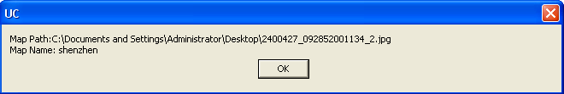

Figure 9-7 Map Property

#### 9.4.2 Devices Property

Choose the device, click right button of the mouse, choose the option of “Property”, after that come out a device property window, as figure 9-8.

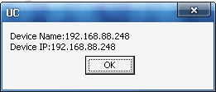

Figure 9-8 Devices Property

## 9.5 Jump among maps

There three methods jump among maps:

* 1. Switch back and forth: click the map name in “map list” which is on the left, then jump to the corresponding map.
  2. Enter sub map: if there is an icon like, click it, then jump to sub map.
  3. Back to the top: click right button of mouse on any where of sub map, choose the option of “back”, the map jump to its father map.

# Chapter 10 Forwarding service setting

## 10.1 Forwarding service setting

Forwarding service to the current UC data server forwarding to distal UC client. In the main interface click on the top right cornerbutton, popup menu select "System Configuration" - " Forward Service Setting". In "Forward Service Setting" interface UC will automatically search to the machine's IP address displayed in the local address bar, set “Local Port”, “Number of” and “User Count”, checked after, click the "ok" button forwarding service can take effect. If you want to cancel the forwarding service is put outcheck, in click "ok" can stop forwarding service. If the "Number of" or "User Count" modified, simply click on "modify" button effect.

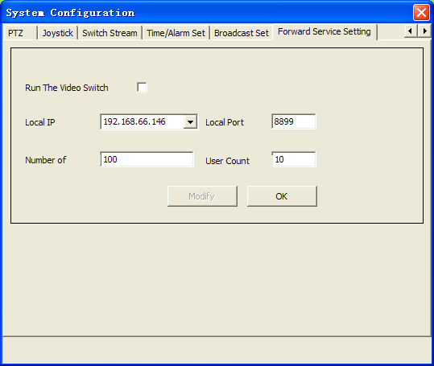

Figure10-1 Forward Service Setting

**Note:** 1. If you need to public network remote forward, it must be in the router to forward the local mapping server IP address and port, public network remote client UC with public network IP address and mapping port receiving and delivering data.

2. Sign platform have no Forward Service Setting function.

## 10.2 Remote client receiving and delivering configuration

UC remote client to receiving and delivering server data, must be in remote client "Config Management" - "Device Config" page configuration add forwarding servers, as below:

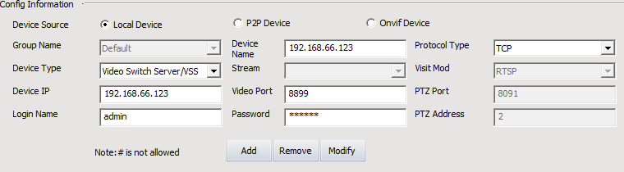

Figure10-2 Add Forward Server

In the device type drop-down box select "Video Switch Server/VSS", input device name, select protocol type, configuration device IP for forwarding the server address (if public network forwarding, must complete and public network address), the video port forwarding servers for the local port (if public network forwarding, must complete and mapping port), login name and password for remote UC client user name and password, click "Add" can add connection already open forwarding service device to the left device list. As below:

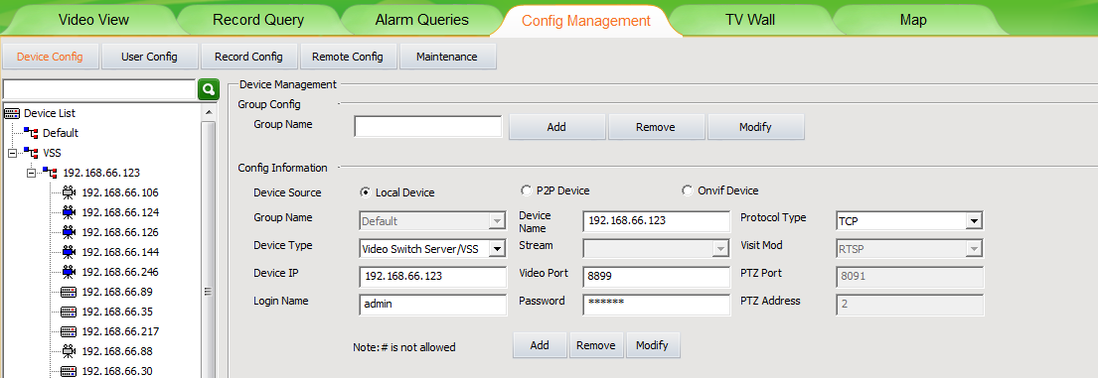

Figure10-3 Forward Server Device List

Add forward server, other functions and operation with local client similar, one no longer give uncecessary details

## 10.3 Forward device video query, playback, Download function

1. On the server side to add video device and device configuration strategy, open video recording device;
2. On the client to add the remote equipment, 【Record Query】 video query into the interface;
3. Select configuration has video devices, click on the "query”;
4. Double-click the query results in the remote video file playback video device;
5. Check the video file, click on "start download" remote device video file can be downloaded to the local (video stored in the Record \ VSS );

* Note：Is playback of the video file connot be downloaded.

# Chapter 11 Multi-screen display

## Multi-screen display

Multi-display control is to point to in multiple display extended play streaming video, record query and playback, alarm message, config management, TV wall, map function. These displays united by a host control, maximum four screen display (such as digital matrix). The realization of screen display need according to different needs in the host connection of multiple video card, each video card at the same time the most connecting two table display. After connected monitor, login UC, the software will automatically recognize the number of monitor.

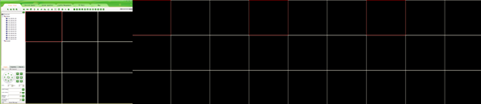  
Figure11-1 Default more display interface

In addition to the main screen video preview interface outside, you can move any function into extend monitor. In the main function on the menu than the current function menu select need to move extended interface, click right button, then come out a pop-up box, as following figure, choose the number of the extend monitor, then this interface move into the extend monitor. If the interface has moved to extend monitor, click it in main monitor will have no function. The moved interface you can operate it just the same as it in main monitor. When you need it come back to main monitor, just click it on main monitor and right click mouse, click the selected extend monitor, then it come back main interface. When your host just with a monitor, right click mouse will not come out the following window.

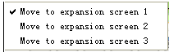

Figure11-1 Extension show

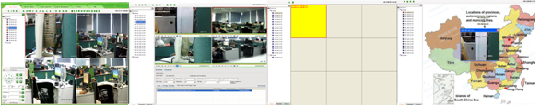

Figure 11-3 extension display effect

**Note:** When in multi-screen environment, if you need to use PTZ function, the device video must be played in main screen.

# Chapter 12 Setting

### 12.1 Automatic Login

Automatic login premise is to save the user password, if want to open the UC automatic login, in the login interface "automatic login" check box to choose and will automatically checked save password, or in the main interface "" click "automatic login".

Cancel the automatic login again in the main interface "" click "√automatic login".

### 12.2 Boot Automatically

If you want to run startup autorun login UC, in the main interface "" click "boot automatically" can. Cancel the startup autorun is again in the main interface "" click "√boot automatically", but automatic login not cancelled, if want to cancel must click again on the tick "√automatic login".

### 12.3 Storage Setting

Player Patrol means that configure many devices to round of play for different window. Click the “” button in the upper right corner of the main interface, popup menu select "System Configuration" - "Storage", in the "Storage" interface click on the "browser" button, the user can choose according to their own needs the local path, choose good after click "save" setting is effective.

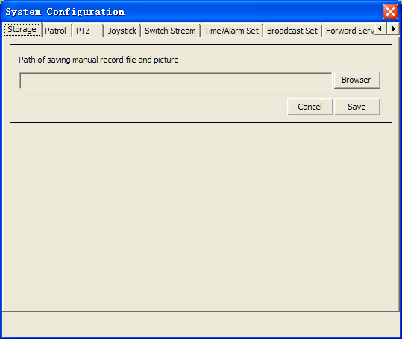

Figure 12-1 Store path settings

Before you setting the storage path, the video files are saved in the “Video” directory that under the file of theinstallation program; the pictures are saved in the “Picture” directory that under the file of theinstallation program. After setting the path, all video files and pictures are saved in set path. In the UC software, there are many places will product videos and pictures, but a user just need to set the storage path one time, then all videos and pictures will be saved in this path.

### 12.4 Patrol setting

Patrol Setting including two side: Player Patrol and TV Patrol. The TV Patrol has described in “TV Wall”, we won’t repeat it.

Player Patrol means that configure many devices to round of play for different window. Click the “” button, popup menu select "System Configuration" - "Patrol", in the "Patrol" interface choose "play Patrol".

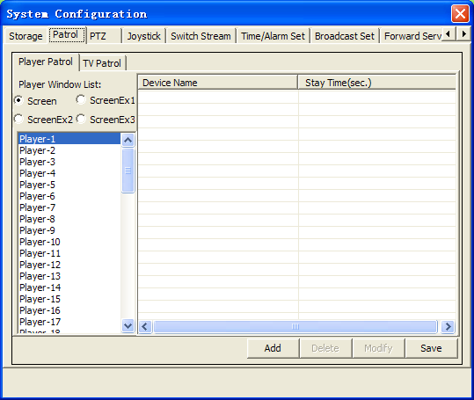

Figure 12-2 play round tour Settings window

The patrol is based on play window, so you can set different patrols for different windows. First, choose the window you need to patrol; second, click the “Add” button; then come out the “Add Patrol” dialog. In this dialog, you can choose the device you need to enter patrol and set the stay time, click “Add” then you have added a device successfully. Every window can only add 10 devices to patrol at most. The following figure is “Add Patrol” dialog.

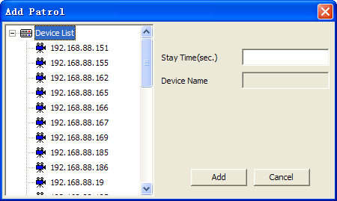

Figure 12-3 Add patrol dialog

After setting the patrol for window, if you think the device you added is too many, you can choose a device, then click “Delete” button, that you will delete a device; if you need to modify the device or their stay time, the “Modify” button will help you.

After setting the patrol, return to 【Video View】 interface, selected window, click video tool in the article "" tour can wheel.

### 12.5 Switch Stream

Switch stream can make UC in video view interface video window by split-screen conversion for single picture subcode flow whether conversion is given priority to code flow, Display the last frame when video loss, Grab save format, Start the extended screen functionality, Need enter password when exiting. In the main interface top right click "" button, popup menu select "System Configuration" - "Switch Stream", in “Switch Stream” checked Settings dialog box can be effective.

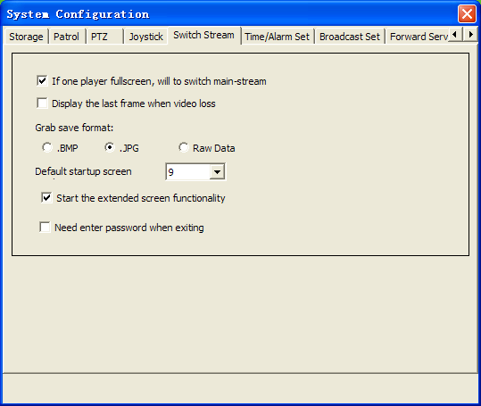  
Figure 12-4 screen setup dialog

### 12.6 Broadcast Set

Add broadcast device, audio encoding format have two kinds of forms: G711 and AAC.

Broadcast set means for different configuration broadcast function. In the main interface top right click on the "" button, the popup menu select " System Configuration " - "Broadcast Set", in the "Broadcast Set" interface configuration requires the broadcasting device. Add broadcast device, should first check the device audio encoding format, then in the original device list checked device added to the left of broadcast device list, after completion of the click "ok".

After setting the broadcast, return to 【Video View】 interface, selected window, click video tool in the article "" tour can wheel.

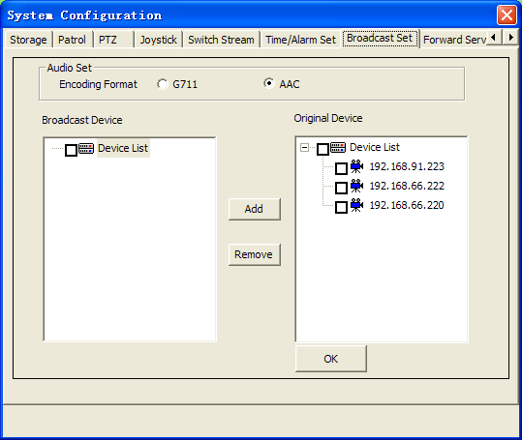

Figure 12-5 radio set

### 12.7 Time/Alarm Set

Time/Alarm Set include alarm sound, device offline alarm and time setting.

Alarm Set can make UC in device alarm when they make alarm sound and open alarm linkage is sent from the alarm switch between voices. In the main interface top right click on the "" button, the popup menu select “System Configuration” - "Alarm Set", in the "Alarm Set" checked Settings dialog box can be effective.

Time setting can synchronize the system time.

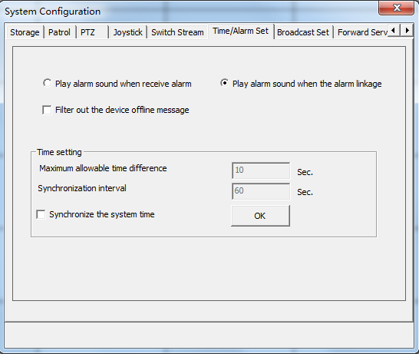

Figure 12-6 time/alarm Settings

### 12.8 About

In the main interface, you can click "" and "About" to view the UC version.

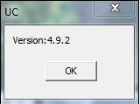

Figure 12-7 on version information

### 12.9 UC Help

In the main interface click "", popup menu select" help" as well as in the start menu program UC directory can open" UC help".